SIMATS ENGINEERING
Department of Information Technology CSA0405 – Operating Systems ASSIGNMENT 2 – CO2

Evaluate and Justify Process-Management and Deadlock-Handling Designs
CO2: Analyze process management and deadlock handling techniques to improve CPU utilization and system performance

Student Name | Akash B | Register Number | 192511257
Department / Section | CSE / A | Academic Year / Semester | 2025
Faculty Name | Dr. Jayasakthi Velmurugan K | Nature of Assignment | Individual
Duration | 1 Week | Total Marks | 50
Date of Submission | 13/11/2026 | Date of Evaluation | 14/11/2026

MARK SHEET (Rubric-based Evaluation)

Task | Task Title | Max | Marks Awarded | Remarks
Q1 | Processes and Process States | 6
Q2 | CPU Scheduling | 8
Q3 | Threads | 6
Q4 | I n t e r - P r o c e s s Communication | 6
Q5 | Synchronisation: Critical Sections, Semaphores and Monitors | 11
Q6-A | Characterise Deadlock | 2
Q6-B | Compare the Strategies | 3

Task | Task Title | Max | Marks Awarded | Remarks
Q6-C | Apply the Banker’s Algorithm (Complete the Code) | 4
Q6-D | Predict Before Implementing | 1
Q6-E | Measure | 1
Q6-F | Defend the Final Design | 2
 | TOTAL | 50

OVERALL REMARKS

  Student Signature | 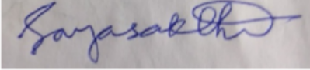  Faculty Signature | Program Director

MANDATORY SUBMISSION EVIDENCE CHECK

Task | Evidence expected | Status | Note
Q1 | State diagram; PCB description; working fork() program with ps evidence; defended design decision
Q2 | Correct Gantt charts and averages for every algorithm; working Round Robin program; quantum study; justified recommendation

Q3 | Working multithreaded program; measured speed-ups for each pool size; evaluation of thread models
Q4 | Two working IPC implementations; measured transfer times; justified choice of method
Q5 | Student-derived synchronisation design; working semaphore code; test evidence; measured, defended locking decision
Q6-A | Correct resource-allocation graph identifying all four conditions
Q6-B | Reasoned comparison of the four strategies for this environment
Q6-C | Working implementation with correct safe sequences and decisions
Q6-D, E | Clear, testable prediction; measured times compared with the prediction
Q6-F | Critical, evidence-based recommendation

MEASUREMENT & IMPLEMENTATION EVIDENCE CHAIN (Q1–Q6)

Evidence item | Status | Observation
Source code (Q1–Q6)

Test inputs / datasets
Expected behaviour
Actual output / screen results
Intermediate algorithmic / measurement evidence
Boundary / failure tests
Interpretation linked to theory
Code, data and report consistent

SUBMISSION CHECKLIST (not separately marked)

Requirement | Status
All questions (Q1–Q6) answered | - Yes ☐ Partly ☐ No
Process-state diagram, PCB and fork()/ps evidence (Q1) | - Yes ☐ Partly ☐ No
Gantt charts, averages and quantum study; Round Robin program completed and run (Q2) | - Yes ☐ Partly ☐ No
Multithreaded program with speed-up for each pool size (Q3) | - Yes ☐ Partly ☐ No
Pipe and shared-memory transfer with 1, 10 and 100 MB timings (Q4) | - Yes ☐ Partly ☐ No
Bounded-buffer code, tests and lock-granularity measurement (Q5) | - Yes ☐ Partly ☐ No
Banker’s algorithm: safe sequence, request decisions and O(m × n²) measurement (Q6) | - Yes ☐ Partly ☐ No
Source code for every program that produced reported data (Q1–Q6) | - Yes ☐ Partly ☐ No
Tables and graphs / diagrams for experimental results | - Yes ☐ Partly ☐ No
Figures / screen outputs included in the submission (not only referenced) | - Yes ☐Partly ☐ No

Cross-references and table/figure numbering correct | - Yes ☒ Partly ☐ No
Work consistent throughout | - Yes ☒ Partly ☐ No
No unfilled template placeholders | ☒ Yes ☐ Partly ☐ No
Viva readiness (able to run the programs and explain measurements) | ☒ Yes ☐ No

OPERATING SYSTEMS

ASSIGNMENT 2 – CO2
CO2 Coverage: Analyze process management and deadlock handling techniques to improve CPU utilization and system performance
Nature of Assignment: Individual
Duration: 1 Week

Total Marks: 50
Submission Date: 13/11/2026
Bloom’s Levels Assessed: K5 – Evaluate (every task in this assignment is at K5 level)

Mandatory Execution and GitHub Submission
- Every student must individually execute every task in this assignment, including all “Complete the Code” programs.
- Create a GitHub repository named CSA0405-<RegisterNumber>-Assignment2 and share it with the course faculty (public, or private with the faculty added as a collaborator).
- Keep one folder for each task (for example: Task01, Task02 … or Q1, Q2 …), containing the C source files, shell scripts, configuration files (Dockerfile, YAML), command outputs and screenshots.
- Include a README.md with your name, register number, compiler and version (for example gcc 13), the Linux distribution and version used, the exact gcc command used to compile (for example gcc -std=c11 - Wall -Wextra -pthread), the steps to run each program, and a short note of the result of each task.
- Commit your work progressively – at least one commit for each task. The commit history will be checked; a single upload of all files on the last day will not be accepted.
- Submit the GitHub link below and on the cover page of your report. An assignment submitted without a working GitHub link will not be evaluated.

GitHub Repository Link: https://github.com/192511257simats-bot/CSA0405-Operating-System.git

How to Answer the Additional Questions
Complete the Code: Copy the given code into your repository, replace every TODO with working code without changing the rest of the program, execute it and compare your output (or result) with the expected output.
Alternative Concept and Complexity Analysis: Describe how the solution would change if the alternative concept were used, with code or pseudocode, and analyse and compare the time complexity and space complexity of both solutions using Big-O notation, supported by your own measurements wherever possible.

Q1 – Processes and Process States (Online Examination Server)

Q1.1 Process-state diagram and PCB
A process is a program in execution. During its life it moves between five states: new (being created), ready (waiting for a CPU), running (executing instructions), waiting (blocked for I/O or an event) and terminated (finished, resources being reclaimed).
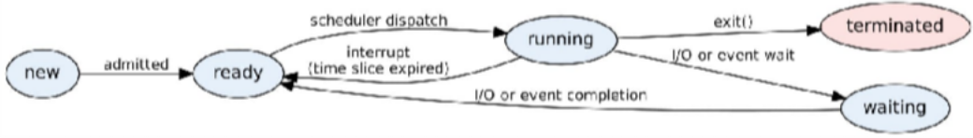
Figure 1: Process-state diagram (five-state model)
The kernel keeps one Process Control Block (PCB) per process (Linux: task_struct). It is what makes a context switch possible: the state of the outgoing process is saved in its PCB and the incoming one is restored from its own.
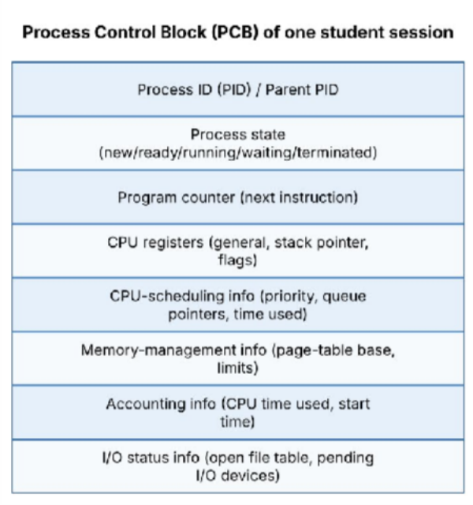
Figure 2: Fields of a Process Control Block
On Linux the PCB can be observed through /proc/<pid>/status (Name, State, Pid, PPid, VmSize, VmRSS, context-switch counters) – used as evidence below.

Q1.2 Program: creating student-session processes with fork()
fork_demo.c creates N child processes. Each child represents one student session: it prints its PID/PPID, sleeps (state *waiting*) and exits with its own code; the parent reaps each child with waitpid(). While the program was running, it was observed with ps and /proc.
int n = argc > 1 ? atoi(argv[1]) : 5;
int hold = argc > 2 ? atoi(argv[2]) : 6; /* seconds children stay alive */ pid_t kids[64];
printf("parent (server) pid=%d creating %d sessions\n", getpid(), n); fflush(stdout);
for (int i = 0; i < n; i++) { pid_t pid = fork();
if (pid < 0) { perror("fork"); exit(1); }
if (pid == 0) { /* child = one student session */
printf(" session %d: pid=%d ppid=%d\n", i + 1, getpid(), getppid()); fflush(stdout);
sleep(hold); /* state: waiting (sleeping) */
_exit(i); /* state: terminated */

}
kids[i] = pid;
}
for (int i = 0; i < n; i++) { int st;
waitpid(kids[i], &st, 0);
printf("parent: reaped pid=%d exit code=%d\n", kids[i], WEXITSTATUS(st));
}
return 0;
}

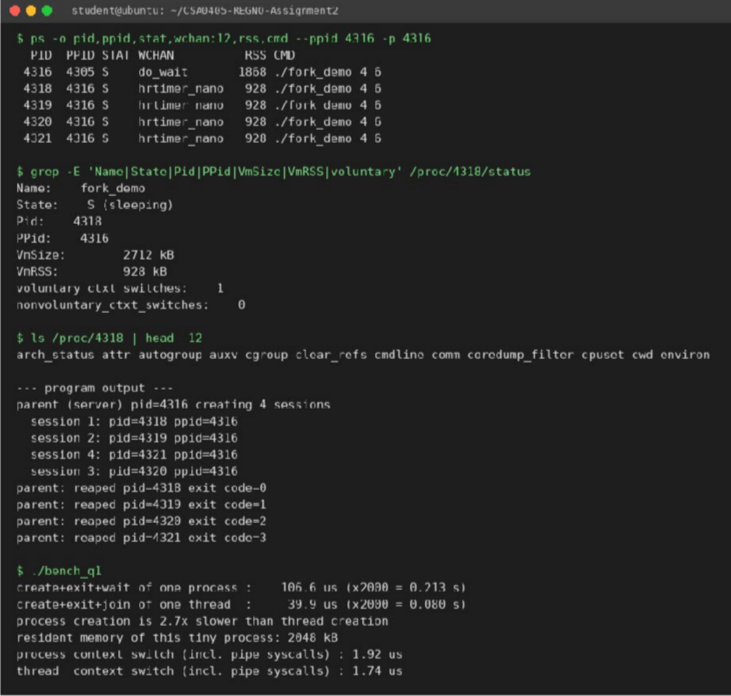
Figure 3: Q1 evidence – fork program, ps listing, /proc/<pid>/status and benchmark output
Reading the evidence. ps shows the parent (PID 4316, state S, waiting in do_wait) and four children with PPID 4316 (state S, sleeping in hrtimer_nanosleep). /proc/4318/status shows State: S (sleeping), PPid: 4316, VmSize ≈
2.7 MB, VmRSS ≈ 0.9 MB and its own context-switch counters – i.e. one PCB per process, with a private address space.

Q1.3 Evaluation – where does the time go with 2,000 active processes?
bench_q1.c measures process creation, thread creation and context-switch cost on this machine (both sides pinned to one CPU, so the switch is real). Results are in the last block of Figure 3.
Table 2: Measured costs (this machine)
Quantity | Process | Thread
Create + exit + wait/join (one) | 106.6 µs (2000 → 0.21 s) | 39.9 µs (2000 → 0.08 s)
Context switch (pipe ping-pong, includes 2 syscalls) | 1.92 µs | 1.74 µs

Quantity | Process | Thread
Memory of a minimal instance | ≈ 0.9–2 MB resident, own page tables | stack only (touched part: a few KB); code/heap shared

Analysis (2,000 sessions):
- Context-switch cost. The raw switch is only ≈ 2 µs, but with 2,000 runnable processes on, say, 8 cores and a 3 ms time slice every process waits about 2000 × 3 ms / 8 ≈ 750 ms for its next turn, and every switch to another address space flushes TLB entries and evicts cache lines, so the effective cost is several times the raw 2 µs. This is why sessions “hang”: latency grows linearly with the number of runnable processes.
- Memory per process. A minimal process already costs ≈ 0.9–2 MB resident plus kernel structures (task_struct, kernel stack, page tables). A real exam session with its own buffers (say 30 MB – an assumption) would need 2000 × 30 MB ≈ 60 GB, far beyond typical server RAM, so the machine starts swapping – the second cause of hanging.
- Waiting for I/O. Each session spends most of its life in the *waiting* state (network, disk auto-save). Waiting processes cost no CPU but still hold their full memory, so a process-per-student design pays the full memory price for a student who is mostly idle. When many auto-saves hit the disk together, the processes queue behind the same device.
Judgement: one process per student is *not* a sound design at this scale: creation ≈ 0.2–0.3 s in total is acceptable, but memory (O(n) with a large constant), run-queue latency and swap are not.

Q1.4 Design decision
Table 3: Options compared
Option | Memory | Switch / create | Isolation | Verdict
One process per student | Very high (full address space each) | Slowest (≈ 107 µs create) | Strong – a crash kills one student only | Rejected at 2,000 sessions
One thread per student | Low (stack only) | Fast (≈ 40 µs, cheaper switch) | Weak – one bug can kill all sessions | Acceptable but risky
Fixed pool of worker processes (each handling many sessions with threads  / event loop) | Bounded: workers × (shared base + per-session state) | Created once, reused; no fork per login | Medium – a crash costs only 1/W of sessions; supervisor restarts it | Chosen
Decision: a fixed pool of worker processes (workers ≈ 2 × cores), each multiplexing many sessions with threads/non-blocking I/O, plus a separate small process for proctoring video and one for auto-save. Defence: memory is bounded and known in advance, the run queue stays short (≈ number of workers, not 2,000), no process is created per login (no login storm), and a crashing worker affects only its own sessions, which a supervisor restarts and whose answers are recovered from the auto-saved copy.

Q1.5 Alternative concept and complexity – one thread per session
If every student session were a thread inside one server process, the server would call pthread_create() per login (measured: 39.9 µs vs 106.6 µs for a process), the thread would get a stack of a few KB–MB (virtual; only touched pages are resident) instead of a full address space, and switching between threads of the same process does not change the page tables (measured 1.74 µs vs 1.92 µs even in a syscall-dominated test; the saving is larger with cache/TLB pressure).
Table 4: Complexity comparison
 | Process per session | Thread per session
Creation time | O(1) syscalls but copies page tables: grows with address-space size | O(1), independent of heap size
Memory for n sessions | O(n × address space) ≈ n × MBs | O(n × stack) + one shared address space

 | Process per session | Thread per session
Context switch | Save registers + switch page tables + TLB flush | Save registers only (same address space)
Effect of one crash | Only that session dies | Whole process dies – all n sessions lost
Sharing data | Needs IPC (pipes, shared memory) | Direct shared memory, needs locks
Conclusion: threads win on cost, processes win on fault isolation; the worker-pool design takes cost from threads and isolation from processes.

Q2 – CPU Scheduling (Cloud Video-Encoding Service)
Process | TAT | WT | RT
P1 | 8 | 0 | 0
P2 | 11 | 7 | 7
P3 | 24 | 15 | 15
P4 | 14 | 9 | 9
Average | 14.25 | 7.75 | 7.75

Q2.1 Gantt charts and averages for the same job set
Job set used for all algorithms (same as the Complete-the-Code program): P1 arrival 0, burst 8, priority 3; P2 arrival 1, burst 4, priority 1; P3 arrival 2, burst 9, priority 4; P4 arrival 3, burst 5, priority 2 (1 = highest priority). Waiting time WT = TAT − burst; turnaround TAT = finish − arrival; response time RT = first start − arrival. All values below were produced by sched_all.c and cross-checked by hand.
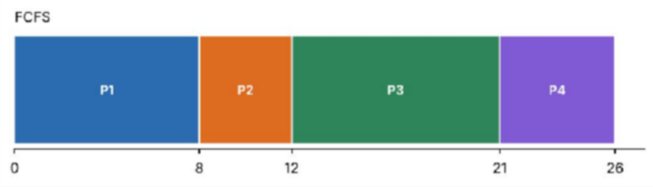
Figure 4: Gantt chart – FCFS
Table 5: FCFS – per-process results
Process | TAT | WT | RT
P1 | 8 | 0 | 0
P2 | 11 | 7 | 7
P3 | 19 | 10 | 10
P4 | 23 | 18 | 18
Average | 15.25 | 8.75 | 8.75
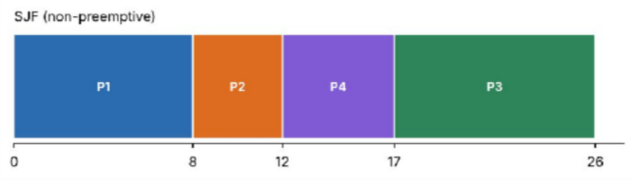
Figure 5: Gantt chart – SJF (non-preemptive) Table 6: SJF (non-preemptive) – per-process results

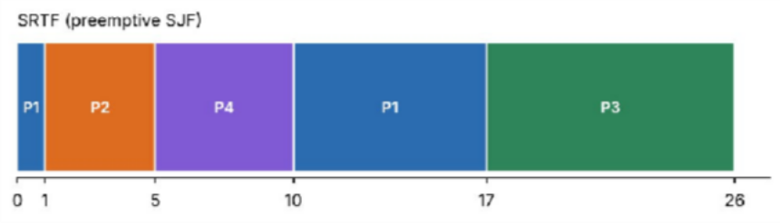
Figure 6: Gantt chart – SRTF (preemptive SJF)

Table 7: SRTF (preemptive SJF) – per-process results
Process | TAT | WT | RT
P1 | 8 | 0 | 0
P2 | 11 | 7 | 7
P3 | 24 | 15 | 15
P4 | 14 | 9 | 9
Average | 14.25 | 7.75 | 7.75

Process | TAT | WT | RT
P1 | 23 | 15 | 0
P2 | 15 | 11 | 2
P3 | 24 | 15 | 4
P4 | 18 | 13 | 6
Average | 20.00 | 13.50 | 3.00

Process | TAT | WT | RT
P1 | 17 | 9 | 0
P2 | 4 | 0 | 0
P3 | 24 | 15 | 15
P4 | 7 | 2 | 2
Average | 13.00 | 6.50 | 4.25
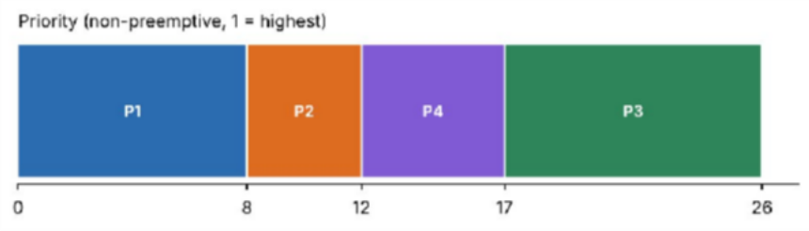
Figure 7: Gantt chart – Priority (non-preemptive) Table 8: Priority (non-preemptive) – per-process results

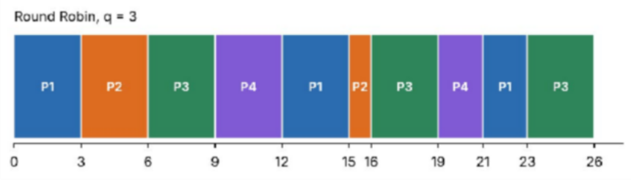
Figure 8: Gantt chart – Round Robin (q = 3) Table 9: Round Robin (q = 3) – per-process results

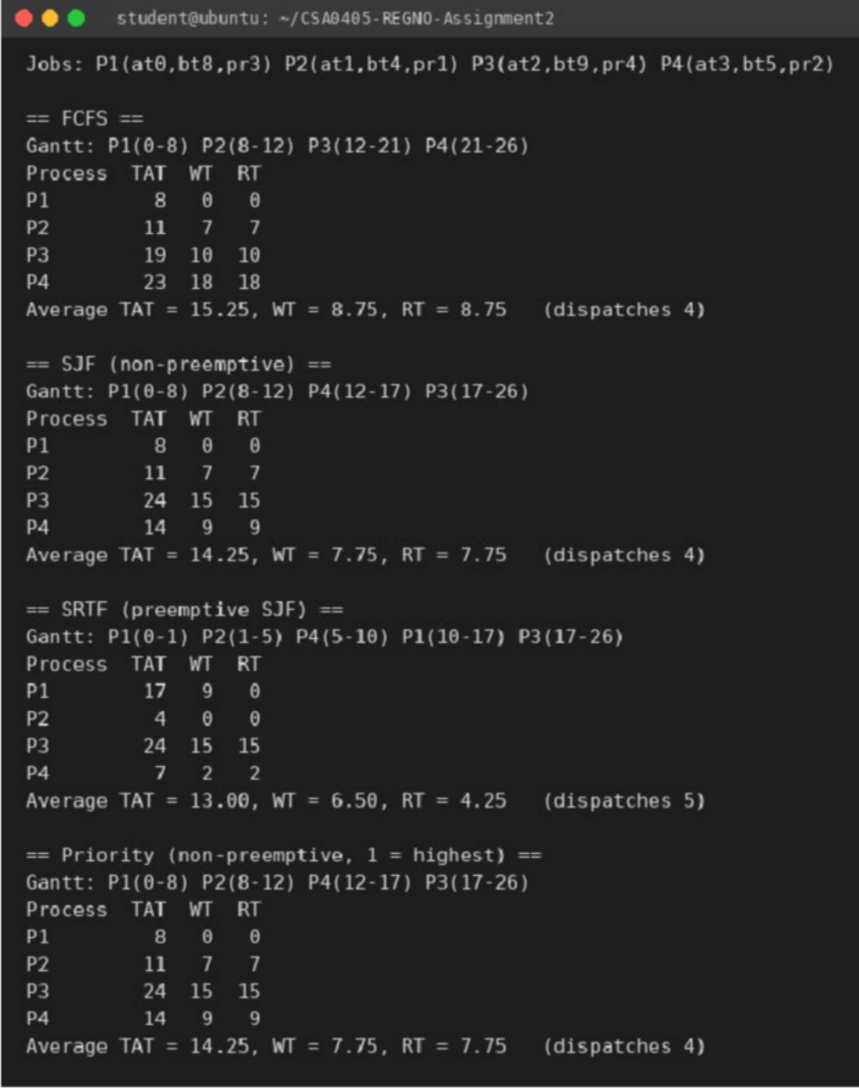
Algorithm | Avg TAT | Avg WT | Avg RT | Remark
FCFS | 15.25 | 8.75 | 8.75 | Short jobs wait behind the long P1 (convoy effect)
SJF | 14.25 | 7.75 | 7.75 | Needs burst length; P3 (longest) waits 15
SRTF | 13.00 | 6.50 | 4.25 | Best averages; P2 waits 0; long job P3 waits 15; 5 dispatches
Priority | 14.25 | 7.75 | 7.75 | Same order as SJF here (priorities follow burst length)
Round Robin q=3 | 20.00 | 13.50 | 3.00 | Best response among fair ones, worst waiting/turnaround

Figure 9: Terminal output of sched_all.c (first part)
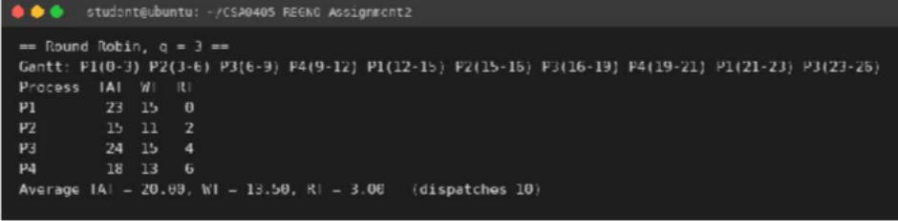
Figure 10: Terminal output of sched_all.c (second part) Table 10: Summary of the five algorithms

Q2.2 Complete the Code – Round Robin (TODO 1)
The TODO was replaced without changing the rest of the program. The #ifdef QUANTUM lines were added only so that the same source could be rebuilt with quantum 1 and 20 (-DQUANTUM=1); with no flag the program is the given one with quantum 3.
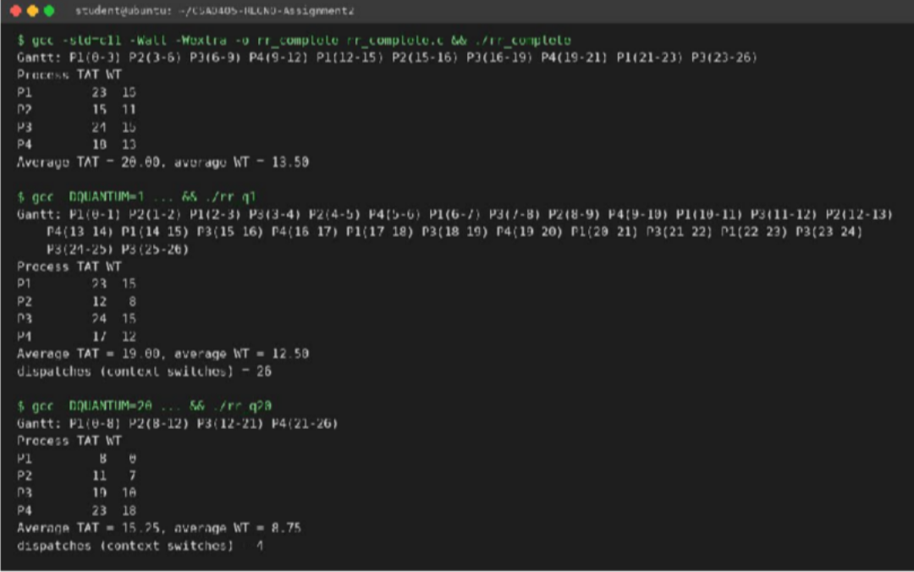
int run = left[p] < quantum ? left[p] : quantum; /* min(quantum, left[p]) */ printf(" %s(%d-%d)", name[p], time, time + run);
time += run; left[p] -= run;
for (int i = 0; i < N; i++) /* admit every newly arrived process */ if (!added[i] && arrival[i] <= time) { queue[tail++] = i; added[i] = 1; }
if (left[p] > 0) queue[tail++] = p; /* back to the end of the queue */ else { finish[p] = time; done++; }

Figure 11: Round Robin output: quantum 3 (identical to the expected output), quantum 1 and quantum 20
The quantum-3 output matches the expected output exactly (Gantt P1(0-3) … P3(23-26), average TAT 20.00, average WT 13.50).

Q2.3 Evaluation – effect of the time quantum (1, 3, 5, 20)
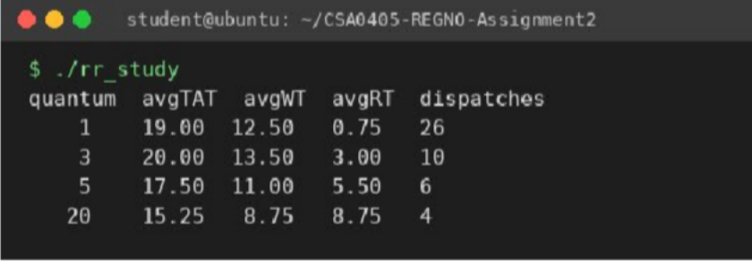
Figure 12: Quantum study output (rr_study.c)

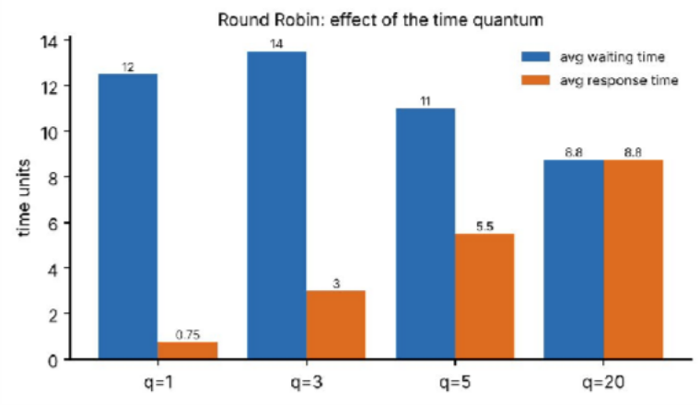
Figure 13: Average waiting and response time against quantum
- Quantum 1: best response time (0.75) but 26 dispatches – the most context-switch overhead (each costs ≈ 2 µs plus cache loss).
- Quantum 20 (larger than every burst): Round Robin degenerates into FCFS – only 4 dispatches, average WT 8.75, but response time rises to 8.75 and short jobs wait behind long ones.
- Quantum 3–5: compromise. Rule of thumb: choose a quantum slightly longer than a typical short job so ≈ 80 % of bursts finish within one slice.
Note that in this small example average WT falls as the quantum grows because overhead is not charged; in real systems the context-switch cost is added to every dispatch, which is why a very small quantum is bad.

Starvation and ageing
SJF/SRTF and priority scheduling can starve a long (or low-priority) job: if short or high-priority jobs keep arriving, the long job is never chosen. In the video service, a 20-minute film would wait indefinitely behind a steady stream of 2-second thumbnails. Ageing fixes this by raising a job’s priority gradually with its waiting time (e.g. +1 priority level every 60 s of waiting), so every job eventually becomes the highest-priority one and is guaranteed to run.

Multilevel feedback queue (MLFQ)
MLFQ keeps several queues with increasing quanta. A new job enters the top queue (short quantum); if it uses its whole quantum it is demoted. Short jobs (thumbnails) finish in the top queue, which has priority; long jobs sink to lower queues with long quanta and run when the top queues are empty. It therefore approximates SJF without knowing burst times in advance.

Q2.4 Design decision for the video service
Calculated averages show SRTF/SJF give the lowest waiting time and RR the best response, while plain FCFS is worst for small jobs. The service cannot know job length exactly in advance (SRTF needs it) and must not starve films. Recommendation: a multilevel feedback queue with ageing (3 levels, quanta 2 s / 10 s / 50 s, periodic boost). This is supported by the video-service simulation below: thumbnails wait 0 s under MLFQ (versus 2,062 s under FCFS and 32 s under RR q=20).

Q2.5 Alternative concept – MLFQ versus single Round Robin (measured)
mlfq.c simulates the video workload (1 time unit = 1 second): two films of 1,200 s and 900 s and eight 2-second thumbnails arriving every 10 s from t = 10 s.

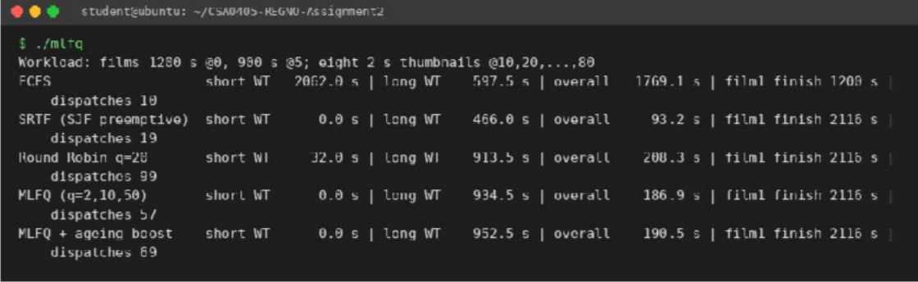
Figure 14: MLFQ simulation output (mlfq.c)
Table 11: Video-service simulation results
Policy | Short-job WT | Long-job WT | Overall WT | Dispatches
FCFS | 2062.0 s | 597.5 s | 1769.1 s | 10
SRTF | 0.0 s | 466.0 s | 93.2 s | 19
Round Robin q = 20 | 32.0 s | 913.5 s | 208.3 s | 99
MLFQ (2/10/50 s) | 0.0 s | 934.5 s | 186.9 s | 57
MLFQ + ageing boost | 0.0 s | 952.5 s | 190.5 s | 69
- Waiting time: MLFQ gives short jobs 0 s waiting, equal to SRTF and far better than RR (32 s) and FCFS (2,062 s). Long jobs wait about as long as under RR (≈ 930 s) because they share the CPU with later arrivals.
- Cost per decision: MLFQ picks the head of the highest non-empty queue – O(1) per decision (O(k) for k queues, k constant). SJF/SRTF must find the shortest remaining job among n ready jobs – O(n) (or O(log n) with a heap). RR is O(1). Space: O(n) for all.
- Starvation: pure MLFQ can starve jobs in low queues if short jobs keep arriving. The periodic boost (ageing) moves everything back to the top queue so a long job is guaranteed progress; in this finite workload nothing starved so the boost only added a little overhead (952.5 s vs 934.5 s long-job WT, 69 vs 57 dispatches) – its value is the *worst-case guarantee* under sustained load.
Conclusion: MLFQ with ageing meets both company goals – small jobs never wait behind films and the processors are fully used.

Q3 – Threads (Traffic-Camera Number-Plate Reader)

Q3.1 What threads share and what they own
Table 12: Shared and private resources of threads in one process
Shared by all threads of a process | Private to each thread
Code (text) segment | Thread ID and thread control block
Global / static data and heap | Program counter
Open files, sockets, file descriptors | CPU register set
Signal handlers, current directory, process ID | Stack (local variables, return addresses)
Address space (page tables) | Thread-local storage, errno, signal mask

Q3.2 User-level and kernel-level threads; thread models
- User-level threads are managed by a library without kernel knowledge: creation/switch is very fast (no syscall), but one blocking system call blocks the whole process and threads cannot run on several cores.
- Kernel-level threads are scheduled by the OS: blocking one thread does not block others and they run in parallel on several cores, but creation/switching needs a system call (slower).
Table 13: Multithreading models
Model | Mapping | Advantage | Disadvantage
Many-to-one | Many user threads → 1 kernel thread | Cheap, portable | No parallelism; a blocking call blocks all
One-to-one | Each user thread → 1 kernel thread | True parallelism; blocking is local | Each thread costs a kernel thread (limit on number). Used by Linux/POSIX threads
Many-to-many | M user threads → N ≤ M kernel threads | Parallel and cheap to create | Complex to implement

Q3.3 Program and measured speed-up
plates.c simulates 64 cameras; processing one frame is a CPU-bound hashing loop (stand-in for plate recognition). It runs (a) sequentially, (b) with one thread per camera (64 threads) and (c) with a pool of 4, 8 and 16 threads that take camera numbers from a shared atomic counter. A checksum of all results proves that every variant processed every camera correctly.
static void *pool_worker(void *a){ (void)a;
int c; while ((c = atomic_fetch_add(&next_cam, 1)) < CAMERAS) results[c] = process_frame(c); return NULL; }
...
for(int i=0;i<n;i++) pthread_create(&th[i],NULL,pool_worker,NULL); for(int i=0;i<n;i++) pthread_join(th[i],NULL);

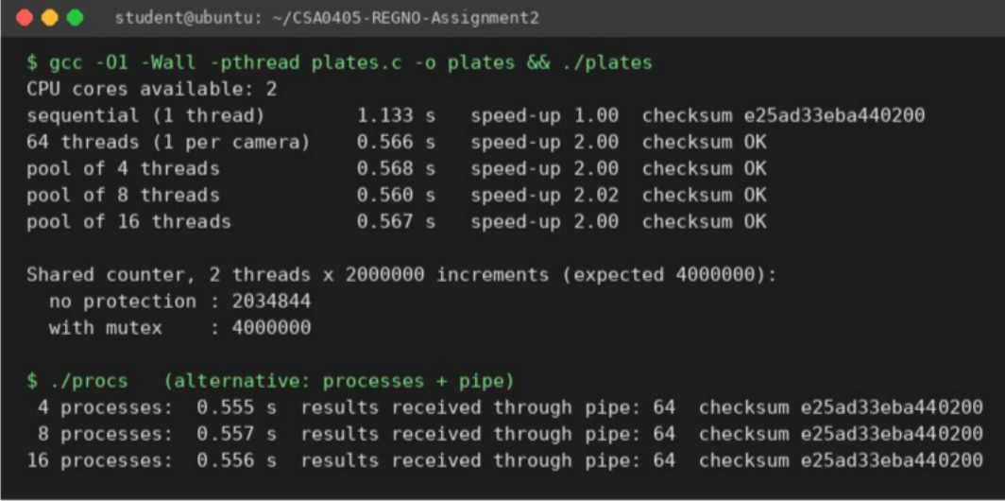
Figure 15: Q3 evidence – speed-ups, race demonstration and the processes-and-pipe alternative
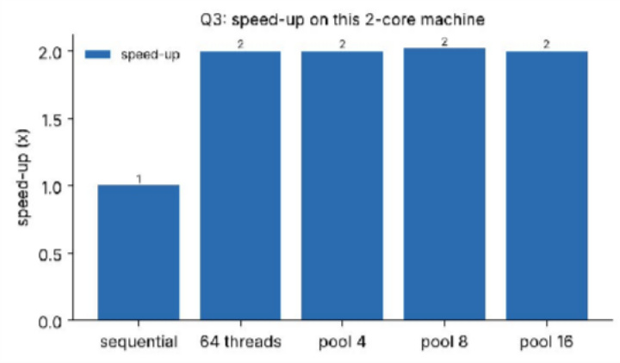
Figure 16: Measured speed-up (relative to the sequential version)
Why the speed-up stops at ≈ 2×: this machine has only 2 CPU cores. The work is CPU-bound, so once there are as many runnable threads as cores, extra threads (8, 16 or 64) can only share the same two cores; they add creation and switching cost but no extra throughput. By Amdahl’s law, speed-up ≤ 1/((1−p)+p/N) with N = 2 cores (≈ 2.0 for p ≈ 1), which matches the measurement. On a machine with more cores, or for I/O-bound frame loading, the pools of 8 and 16 would continue to help until the cores or the I/O device saturate. 4 threads would also need only a few KB of stack each.

Q3.4 Shared counters without protection
Two threads each executed counter++ two million times. The expected result is 4,000,000.
- No protection: result 2,034,844 – almost half of the updates were lost. counter++ is three steps (load, add, store); if both threads load the same value, one increment is overwritten. This is a *race condition*.
- With a mutex: result 4,000,000, correct, at the price of serialising the update.
(The counter is declared volatile in the demo only to stop the compiler turning the loop into a single addition; the race is in the hardware read-modify-write sequence.)

Q3.5 Alternative concept – several processes instead of threads
procs.c processes the same 64 frames with 4, 8 and 16 child processes; each child writes its result into a pipe and the parent reads and combines them (visible in the second half of Figure 15).
Table 14: Threads versus processes for the camera workload
Aspect | Threads | Processes (+ pipe)
Time for 64 frames (CPU-bound) | ≈ 0.56 s | ≈ 0.56 s (same – bounded by 2 cores)

Aspect | Threads | Processes (+ pipe)
Creation time (Q1 measurement) | ≈ 40 µs | ≈ 107 µs
Context switch | cheaper (no page-table switch) | dearer (address-space switch)
Memory | one address space, small stacks | separate address spaces (copy-on-write copies of the parent)
Combining results | shared array + atomic/mutex – no copy | IPC (pipe: two copies through the kernel); 64 results of 8 bytes is negligible but large frames would not be
Fault isolation | a bad frame can crash all threads | a crashing child affects only its own frames
Complexity: both are O(F) total work for F frames spread over p workers ≈ O(F/p + p) time (the + p is creation overhead), and O(p) memory for stacks; processes have a larger constant in memory and creation time, plus O(F) IPC messages. Conclusion: threads are the better fit for this shared-result, CPU-bound task; processes are preferable only if recognition libraries are unsafe to run in one address space.

Q4 – Inter-Process Communication (Weather Station Pipeline)

Q4.1 Pipe: complete the code
The sensor-reading process (parent) writes six readings into a pipe and the analyser (child) reads them one int at a time until read() returns 0.
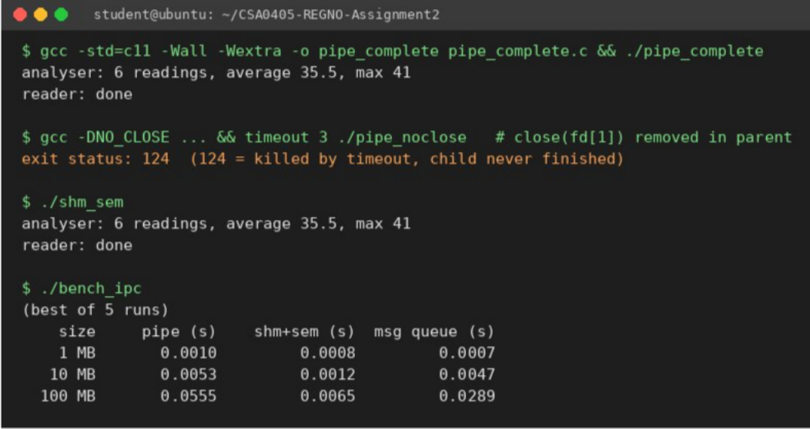
int v;
while ((r = read(fd[0], &v, sizeof v)) > 0) { /* r == 0 -> every write end closed = end of data */ count++;
sum += v;
if (v > max) max = v;
}

Figure 17: Q4 evidence – pipe result, missing close(fd[1]) hang, shared memory + semaphore, transfer benchmark
Output equals the expected output: analyser: 6 readings, average 35.5, max 41 and reader: done.

Why does removing close(fd[1]) in the parent make the child hang?
read() on a pipe returns 0 (end-of-file) only when every write end of the pipe is closed. If the parent keeps fd[1] open, the kernel must assume it may still write, so after the six readings the child’s read() blocks forever waiting for more data. The parent in turn waits in waitpid() for the child – so both processes wait for each other (a deadlock). In the test (Figure 17) the program printed nothing and had to be killed by timeout (exit status 124). The fix is the line close(fd[1]), which doubles as the “end of data” signal.

Q4.2 Questions on the models
- How the pipe signals end of data: by closing the last write end; the reader’s read() then returns 0 after the buffered data is consumed.
- Shared memory versus message passing: in shared memory two processes map the same physical pages and communicate by ordinary reads/writes – the kernel is involved only at set-up. In message passing (pipe, message queue) every transfer is a system call and the kernel moves the data.
- Which copies data: pipe and message queue copy twice (sender buffer → kernel buffer → receiver buffer). Shared memory copies nothing through the kernel.
- Which needs extra synchronisation: shared memory – the kernel does not know when data is complete, so the processes need semaphores/mutexes to avoid reading a half-written slot or overwriting unread data. Pipes and message queues synchronise implicitly (the reader blocks when empty, the writer blocks when full).

Q4.3 Alternative – shared memory with a semaphore
shm_sem.c places a ring buffer of 8 ints and two semaphores (empty = free slots, full = filled slots) in mmap-shared memory. The producer does sem_wait(empty); write slot; sem_post(full), the consumer the reverse; the value −1 marks end of data. It prints the same result as the pipe (Figure 17).

Q4.4 Growth investigation – 1, 10 and 100 MB
bench_ipc.c moves 1, 10 and 100 MB from the parent to the child with a pipe (64 KB writes), shared memory + semaphores (16 slots × 64 KB) and a POSIX message queue (8 KB messages). Each figure is the best of 5 runs and the child checks that it received exactly the right number of bytes.
Table 15: Transfer time in seconds (best of 5)
Size | Pipe | Shared memory + semaphore | Message queue
1 MB | 0.0010 | 0.0008 | 0.0007
10 MB | 0.0053 | 0.0012 | 0.0047
100 MB | 0.0555 (≈ 1.8 GB/s) | 0.0065 (≈ 15 GB/s) | 0.0289 (≈ 3.5 GB/s)
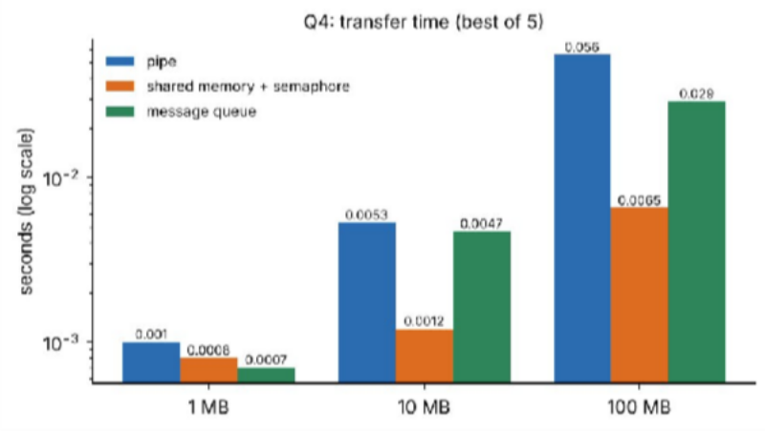
Figure 18: Transfer time versus data size (log scale)
Evaluation. All methods grow linearly with size (≈ 10× data → ≈ 10× time for 10 → 100 MB), i.e. O(n). Shared memory has the smallest slope: ≈ 8.5× faster than the pipe at 100 MB because the payload is written once and read in place (one memory copy by the producer, none by the kernel), while the pipe pays two kernel copies plus a system call per 64 KB. At 1 MB the differences are within timer noise (≈ 1 ms). In this run the message queue was faster than the pipe; I believe this is due to its different buffering/wake-up pattern (kernel queue of 10 × 8 KB), not to fewer copies – I did not investigate further.

Q4.5 Complexity and choice of method
Transferring n readings costs O(n) for both, but with a constant of 2 copies + n/B syscalls for the pipe (B = write size) versus 1 copy and only semaphore operations for shared memory (a sem_wait/sem_post pair per slot, which is a futex system call only when contended). Space: pipe O(buffer) in the kernel (64 KB default); shared memory O(ring size) in user space. Synchronisation: none for pipe, explicit semaphores for shared memory.
Justified choice: weather readings are tiny (a few ints per second), so the pipe’s simplicity, built-in blocking and automatic end-of-data signal outweigh its copy cost – use a pipe for the sensor stream. If the station ever sends bulk data (images, radar sweeps of tens of MB) switch to shared memory with semaphores, where the measured advantage is ≈ 8× at 100 MB.

Q5 – Synchronisation: Critical Sections, Semaphores and Monitors (Railway Ticket Booking)

Q5.1 Design from the principle
Principle: a critical-section solution must guarantee mutual exclusion (at most one process inside), progress (if nobody is inside, a process that wants to enter is not postponed indefinitely by processes that do not want to enter) and bounded waiting (a limit on how many times others may enter before a waiting process does). Design: every access to the shared seat map or counter is wrapped as entry section → critical section (check seat free, mark it sold) → exit section → remainder.

Peterson’s solution (two processes)
flag[i] = 1; turn = j;
/* I want in, but you go first */
while (flag[j] && turn == j) ; /* wait */
/* critical section */ flag[i] = 0;
- Mutual exclusion: both inside would need flag[0]=flag[1]=1 and, from the last writes, turn==0 and turn==1
at the same time – impossible, since turn holds one value.
- Progress: if P_j is not interested (flag[j]=0) the loop condition is false and P_i enters at once.
- Bounded waiting: after P_j leaves and wants back in, it sets turn=i, so P_i gets in after at most one entry of P_j.
- Why it may fail on modern processors: compilers and CPUs reorder memory operations. The store flag[i]=1 may sit in the store buffer while the following load of flag[j] runs, so both processes see the other’s flag as 0 and both enter. peterson.c demonstrates this: with plain variables the counter ended at 1,999,964 instead of 2,000,000 (36 lost updates); with sequentially consistent atomics (which insert the required memory barriers) the result was exactly 2,000,000.
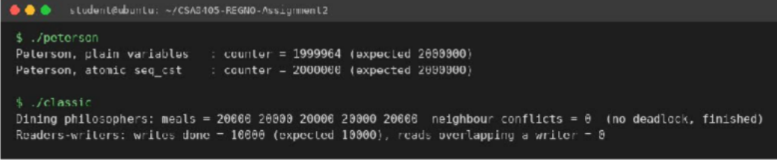
Figure 19: Peterson demonstration, dining philosophers and readers–writers output

Semaphores protecting the seat counter
- A counting semaphore seats = N represents free seats: wait(seats) before booking (blocks when sold out, so overselling is impossible), the cancel operation does signal(seats).
- A binary semaphore (mutex) m = 1 protects the seat map: wait(m); mark seat; signal(m); so two agents cannot take the same seat number.

Classic problems with semaphores
- Bounded buffer: empty = SIZE, full = 0, mutex = 1. Producer: wait(empty); wait(mutex); insert; signal(mutex); signal(full); consumer the mirror image. (Implemented and tested below.) The order wait(empty) *before* wait(mutex) is essential – the opposite order can deadlock.
- Readers–writers (readers preference): rw_mutex = 1, mutex = 1, readcount. First reader locks rw_mutex, last reader releases it; a writer takes rw_mutex. Tested in classic.c: 4 readers + 2 writers, 10,000 writes completed and 0 reads overlapped a writer. Weakness: writers can starve.
- Dining philosophers: one semaphore per fork plus a room semaphore initialised to 4, so at most four philosophers compete and the circular wait is impossible. Tested: five philosophers ate 20,000 meals each, 0 neighbour conflicts, no deadlock (Figure 19).

Monitors with condition variables
A monitor bundles the shared data, the operations and an implicit lock: only one thread is inside at a time, so the programmer cannot forget the mutex. Waiting is expressed with condition variables. For the booking system:

monitor Booking {
int free_seats; condition seat_available;
void book() { while (free_seats == 0) wait(seat_available); free_seats--; } void cancel() { free_seats++; signal(seat_available); }
} /* POSIX equivalent: pthread_mutex_t + pthread_cond_wait(&c,&m) / pthread_cond_signal(&c) */
It is easier to get right because mutual exclusion is automatic and the |  |  | while | -re-check pattern removes the lost-  oss the code.
wakeup and ordering errors that appear when | wait/signal | are scattered acr |  | -re-check pattern removes the lost-  oss the code.

Q5.2 Complete the Code – bounded buffer (TODO 1 and TODO 2)
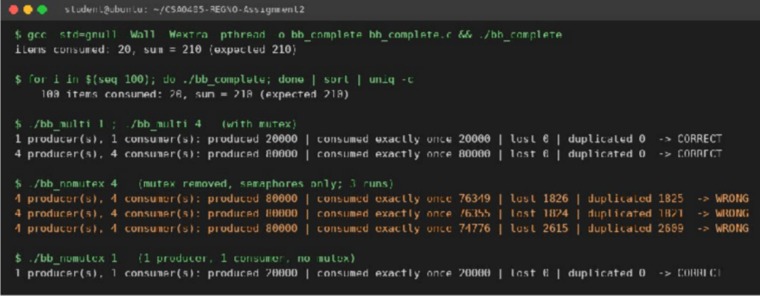
/* TODO 1 – producer */ /* TODO 2 – consumer */
sem_wait(&empty); sem_wait(&full); pthread_mutex_lock(&lock); pthread_mutex_lock(&lock); buffer[in] = item; int item = buffer[out];
in = (in + 1) % SIZE; out = (out + 1) % SIZE; pthread_mutex_unlock(&lock); pthread_mutex_unlock(&lock); sem_post(&full); sem_post(&empty);
consumed_sum += item;

Figure 20: Bounded buffer: single run, 100 runs, 1 and 4 producers/consumers, and mutex removed
- Expected output items consumed: 20, sum = 210 (expected 210) was produced, and sort | uniq -c over 100 runs shows 100 identical correct lines.
- 1 and 4 producers/consumers (`bb_multi.c`): each item has a unique id and a counter array records how often each id was consumed. With the mutex: 1P/1C – 20,000 of 20,000 consumed exactly once; 4P/4C – 80,000 of 80,000 exactly once (0 lost, 0 duplicated).
- Mutex removed: with 1 producer and 1 consumer the result is still correct – only one thread touches in and only one touches out, and the semaphores alone order the hand-over. With 4P/4C it breaks in every run:
e.g. 76,349 consumed once, 1,826 lost and 1,825 duplicated items (also 2,615 / 2,609 in another run), because two producers read the same in and write the same slot, then both advance it. Semaphores count slots but do not protect the index variables, so the mutex is mandatory with several producers or consumers.

Q5.3 Deployment decision – one lock for the system, per train, or per coach
lockgran.c simulates agents booking random seats on 8 trains × 8 coaches × 64 seats; each booking does a lock, a seat check/mark and about 1 µs of work inside the lock. After every run the program checks that no seat was sold twice.

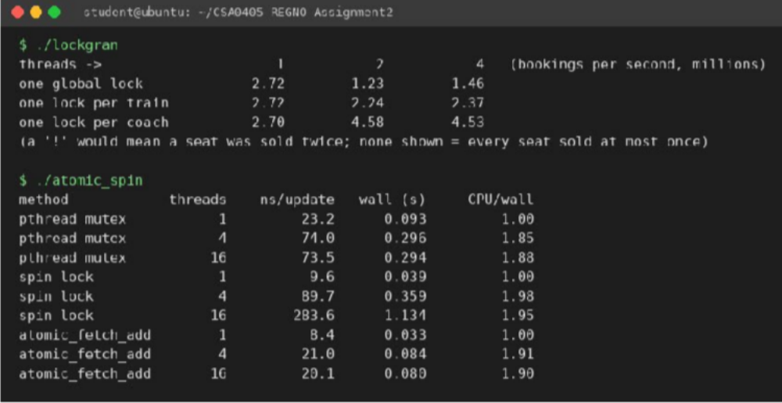
Figure 21: Lock granularity throughput and atomic/spin/mutex measurements
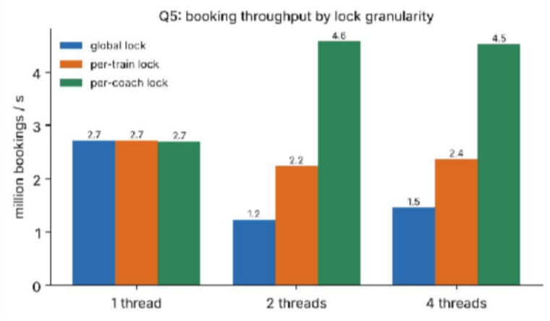
Figure 22: Throughput by lock granularity
Table 16: Bookings per second (millions)
Lock | 1 thread | 2 threads | 4 threads
One global lock | 2.72 | 1.23 | 1.46
One lock per train | 2.72 | 2.24 | 2.37
One lock per coach | 2.70 | 4.58 | 4.53
With one thread all variants cost the same. With 2 and 4 threads the global lock loses throughput (1.23 M/s – below its single-thread value because of lock contention and cache-line bouncing) while the per-coach lock gains
1.7× (4.58 M/s) and is 3.7× faster than the global lock. (This machine has only 2 cores, so 4 threads do not scale further; on a larger server the gap would widen.) Decision: one lock per coach – most parallelism, and bookings on different coaches (the common case) never block each other. Cost: more locks (512 here, trivial memory) and care for operations touching several coaches (group bookings): acquire locks in a fixed global order (train id, then coach id) to avoid deadlock, and use the per-train lock for whole-train operations such as cancelling a train.
Q5.4 Alternative – atomic operations or a spin lock instead of semaphore + mutex
atomic_spin.c performs 4,000,000 counter updates split over 1, 4 and 16 threads using (a) a pthread mutex, (b) a spin lock built from atomic_flag, (c) C11 atomic_fetch_add (output in Figure 21).

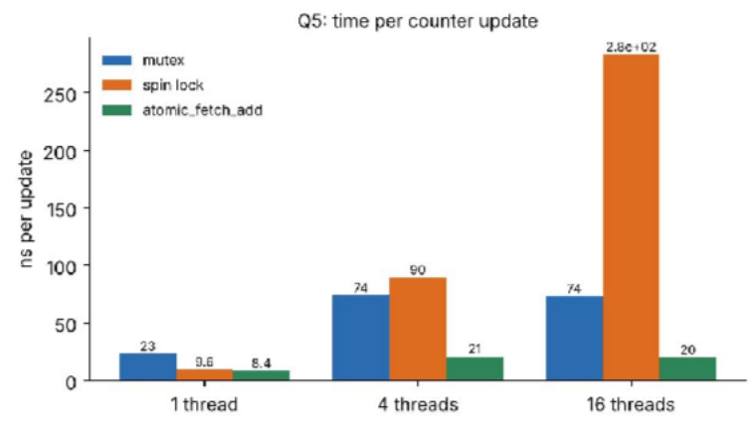
Figure 23: Time per counter update (ns)
Table 17: ns per update, CPU time / wall time
Method | 1 thread | 4 threads | 16 threads | CPU/wall at 16
pthread mutex | 23.2 | 74.0 | 73.5 | 1.88
Spin lock | 9.6 | 89.7 | 283.6 | 1.95
atomic_fetch_add | 8.4 | 21.0 | 20.1 | 1.90
- Time per update: atomic add is fastest everywhere (8.4 → 20 ns): one hardware instruction, no waiting. The spin lock is quick when uncontended (9.6 ns) but degrades badly with 16 threads on 2 cores (283.6 ns): a thread that holds the lock may be pre-empted while the others spin.
- CPU time wasted by spinning: a CPU/wall ratio near 2 means both cores are 100 % busy. For the atomic and mutex versions much of that time is useful (or short futex waits) but for the spin lock almost all of the extra time with 16 threads is pure busy-waiting – the worst useful-work per CPU-second.
- Which suits a long critical section: the mutex/semaphore, because a blocked thread sleeps and gives up the CPU, whereas a spinner burns the CPU for the whole duration. Spin locks and atomics suit only very short sections (a counter increment, a pointer swap).
Complexity: all are O(1) per update uncontended; under contention with k threads the spin lock costs O(k) wasted spin per acquisition, the mutex O(1) CPU plus a context switch, the atomic add O(1) (hardware serialises the cache line). Space O(1) for all.

Q6 – Day-4 Design Challenge: Deadlock Handling and the Banker’s Algorithm

Characterise deadlock (2 marks)
A deadlock exists only if all four necessary conditions hold simultaneously:
  - Mutual exclusion – a GPU, a licence or a storage allocation can be used by one job at a time.
  - Hold and wait – a job holds some resources (e.g. a GPU) while waiting for others (a licence).
  - No pre-emption – a resource cannot be taken from a job; it is released only voluntarily.
  - Circular wait – there is a cycle of jobs J1 → J2 → J3 → J1 each waiting for a resource held by the next. Resource-allocation graph of the cluster. Boxes are resource types (one instance each), circles are jobs; an arrow resource → job means *assigned*, job → resource means *requests*. J1 holds the GPU and wants the licence, J2
holds the licence and wants the fast storage, J3 holds the storage and wants the GPU: the cycle GPU → J1 →
licence → J2 → storage → J3 → GPU with single-instance resources is a deadlock. The graph shows mutual exclusion (single instances), hold-and-wait (green + red arrows at each job), no pre-emption (assignment arrows are fixed) and circular wait (the cycle).
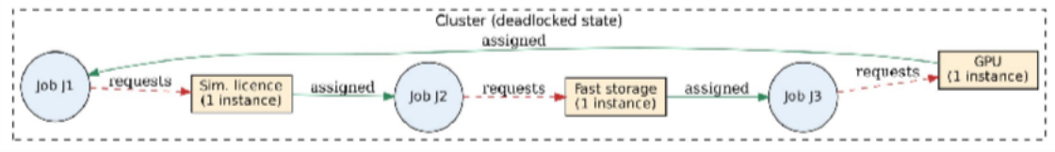
Figure 24: Resource-allocation graph with the deadlock cycle

Complete the Code (TODO 1) – safety algorithm
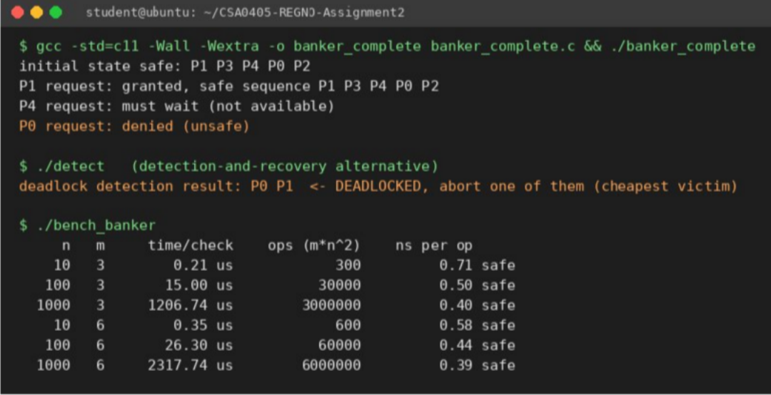
int ok = 1;
for (int r = 0; r < R; r++)
if (maxm[p][r] - alloc[p][r] > work[r]) { ok = 0; break; } /* need <= work ? */ if (ok) {
for (int r = 0; r < R; r++) work[r] += alloc[p][r]; /* p finishes, releases */ finish[p] = 1; seq[count++] = p; found = 1;
}

Figure 25: Q6 evidence – Banker’s algorithm output, deadlock detection, scaling benchmark
The output is identical to the expected output: initial state safe: P1 P3 P4 P0 P2, P1 request granted with the same safe sequence, P4 must wait, P0 denied (unsafe).

Hand calculation – why P0’s request (0, 2, 0) is unsafe
After P1’s request (1,0,2) is granted: Available = (2,3,0). Allocation: P0 (0,1,0), P1 (3,0,2), P2 (3,0,2), P3 (2,1,1), P4 (0,0,2). (P4’s request (3,3,0) cannot be granted because 3 > Available A = 2, so it waits.)

P0 requests (0,2,0). Check 1: request ≤ Need(P0) = (7,4,3) ✓. Check 2: request ≤ Available (2,3,0) ✓. Pretend to grant: Available = (2,1,0); Allocation(P0) = (0,3,0); Need(P0) = (7,2,3).
Table 18: Need = Max − Allocation after pretending to grant P0’s request; Work = Available = (2,1,0)
Process | Need | Need ≤ Work (2,1,0)?
P0 | (7,2,3) | No – 7 > 2
P1 | (0,2,0) | No – 2 > 1 (B)
P2 | (6,0,0) | No – 6 > 2
P3 | (0,1,1) | No – 1 > 0 (C)
P4 | (4,3,1) | No – 4 > 2
No process can finish, so no safe sequence exists: the state is unsafe and the request is denied (the allocation is rolled back). Note that an unsafe state is not yet a deadlock, but it *may* lead to one, so the Banker’s algorithm refuses to enter it.

Alternative – detection and recovery
detect.c shows the alternative: no checks on requests; every few minutes a detection algorithm (same structure as the safety algorithm, but using the *current requests* instead of maximum needs) is run. On a state where P0 holds B and waits for A held by P1, and P1 holds A and waits for B, it reports P0 P1 deadlocked (Figure 25); one of them is then aborted.
Table 19: Banker’s algorithm versus detection and recovery
 | Banker’s (avoidance) | Detection + recovery
Cost per request | O(m·n²) check on every request | None
Periodic cost | None | O(m·n²) every few minutes
Needs maximum demands in advance | Yes | No
Deadlock occurs? | Never | Yes, for up to one detection period
Work lost | None (requests wait) | Aborted job’s completed work (hours of GPU time) must be redone
Resource utilisation | Lower (safe-state restriction delays grants) | Higher

Compare the strategies (3 marks)
Table 20: Strategies evaluated for the research-centre cluster
Strategy | Idea | Strengths | Weaknesses for this cluster | Verdict
Prevention | Remove one condition (e.g. request all resources at once; global resource order; allow pre-emption) | Simple, no run-time checks, guarantees no deadlock | All-at-once wastes expensive GPUs while a job waits for the licence (low utilisation); GPUs/licences cannot be pre-empted without losing work; ordering helps but is easy to violate | Useful in part (ordering/all-or-nothing)
Avoidance (Banker’s) | Grant a request only if the state stays safe | No deadlock, keeps resources shared, high utilisation | Needs maximum demand in advance; O(m·n²) per request; fixed number of resources | Good if jobs declare needs
Detection and recovery | Allow deadlock, detect periodically, abort a victim | Max utilisation, no declared maxima | Lost work of long simulations; cluster stalls until the next detection; recovery is messy | Fallback only
Ignore (ostrich) | Assume deadlock is rare; administrator reboots | Zero cost | This cluster already deadlocks and stops until an administrator intervenes – unacceptable | Rejected

Apply the Banker’s algorithm (4 marks)
The implementation (banker_complete.c) contains both parts: is_safe() is the safety algorithm (Work = Available; repeatedly find an unfinished process with Need ≤ Work, let it finish and release its allocation) and request() is the resource-request algorithm (check request ≤ Need, request ≤ Available, pretend to allocate, run the safety algorithm, roll back if unsafe).
Table 21: Initial state (A,B,C) = (3,3,2) available; decisions
Process | Max | Allocation | Need
P0 | 7 5 3 | 0 1 0 | 7 4 3
P1 | 3 2 2 | 2 0 0 | 1 2 2
P2 | 9 0 2 | 3 0 2 | 6 0 0
P3 | 2 2 2 | 2 1 1 | 0 1 1
P4 | 4 3 3 | 0 0 2 | 4 3 1
Safe sequence of the initial state (hand trace): Work = (3,3,2). P1 (1,2,2) ≤ Work → Work = (5,3,2). P3 (0,1,1) → (7,4,3). P4 (4,3,1) → (7,4,5). P0 (7,4,3) → (7,5,5). P2 (6,0,0) → (10,5,7). Safe sequence ⟨P1, P3, P4, P0, P2⟩ – equal
to the program output.
Table 22: Decisions on the three requests (in order)
Request | Checks | Decision | Reason
P1 (1,0,2) | ≤ Need (1,2,2) ✓, ≤ Avail (3,3,2) ✓ | Granted | New state safe: ⟨P1,P3,P4,P0,P2⟩
P4 (3,3,0) | ≤ Need (4,3,1) ✓, ≤ Avail (2,3,0) ✗ (A: 3 > 2) | Must wait | Resources not available
P0 (0,2,0) | ≤ Need (7,4,3) ✓, ≤ Avail (2,3,0) ✓ | Denied | Pretend-state is unsafe (no process can finish – see hand calculation)

Predict before implementing (1 mark)
Prediction. The safety algorithm has an outer loop of up to n rounds (each round finishes at least one process), an inner loop over n processes, and a comparison/addition over m resources: T(n, m) = O(m × n²). Testable consequences: increasing n by 10× should increase the time by ≈ 100×; doubling m should roughly double the time. Memory is O(n × m) for the matrices.

Measure (1 mark)
bench_banker.c times the safety check in its worst case (a chain in which exactly one process can finish per round, and only the last resource blocks, so every comparison scans all m resources) for n = 10, 100, 1,000 and m
= 3 and 6.
Table 23: Measured time of one safety check
n | m = 3 | m = 6 | Ratio m6/m3
10 | 0.21 µs | 0.35 µs | 1.7
100 | 15.0 µs | 26.3 µs | 1.8
1,000 | 1,206.7 µs | 2,317.7 µs | 1.9

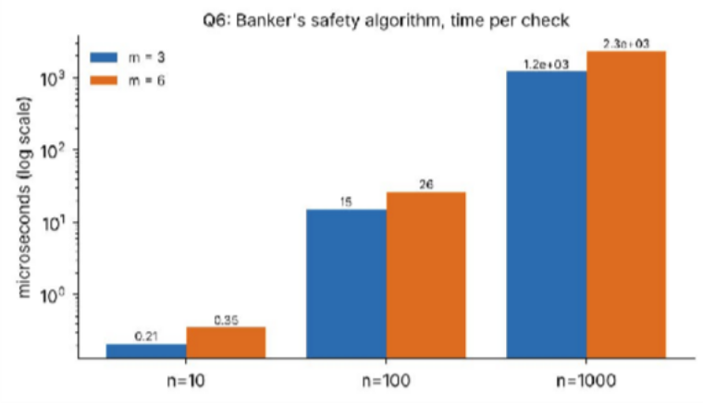
Figure 26: Time per safety check against n (log scale)
Comparison with the prediction: n 10 → 100 multiplies the time by 71 (m = 3) and 75 (m = 6); n 100 → 1,000 by 80 and 88. The predicted factor is 100; the measured factors are a little lower because small cases are dominated by fixed overheads (malloc/free, loop set-up) and the inner loop is cache-friendly, but the growth is clearly quadratic in n (a linear model would give 10×). Doubling m gave 1.7–1.9×, confirming the linear dependence on
m. Prediction confirmed.

Defend the final design (2 marks)

Recommendation: a layered strategy with the Banker’s algorithm (avoidance) at job admission as the main defence, plus all-or-nothing allocation and a detection watchdog.
- Banker’s cost is acceptable. One safety check for 1,000 jobs and 3 resource types costs ≈ 1.2 ms (2.3 ms for 6 types). GPU/simulation jobs run for minutes to hours, so a millisecond per request is negligible, while one deadlock currently stops the whole cluster.
- The real limitation is maximum demand. The algorithm needs every job to declare its maximum GPU, licence and storage need in advance. For batch jobs on a scheduler this is realistic (users already request resources in the submission script); jobs that under-declare must be rejected when they exceed the claim. Interactive or unpredictable jobs cannot declare a maximum.
- Other limits: the number of resources must be fixed and known (a failed GPU changes the state), and avoidance reduces utilisation slightly because some safe-looking requests are delayed.
- Fallbacks for jobs without declared maxima: acquire all three resource types atomically (breaks hold-and-wait – cheap), take licences and storage in a fixed global order (breaks circular wait), and run the O(m·n²) detection every few minutes as a safety net (log + abort the youngest job, checkpointing long jobs so little work is lost).
Rejected: ignoring deadlock (it is already stopping the cluster) and pure detection/recovery as the main strategy (lost simulation work). This recommendation is evidence-based: the algorithm’s cost was measured (Table 23), its growth predicted and confirmed (O(m·n²)), and its correctness demonstrated on the given state (safe sequence, a granted, a waiting and a denied request).

Appendix A – Summary of Results and Conclusions
Table 24: Key result of each question
Q | Key result | Decision
Q1 | fork() demo observed with ps and /proc; process creation 106.6 µs vs thread  39.9 µs | Fixed pool of worker processes
Q2 | RR program matches expected output; averages: FCFS 8.75, SJF 7.75, SRTF 6.50, RR(3) 13.50 WT; quantum study 1/3/5/20 | MLFQ with ageing
Q3 | Speed-up ≈ 2.0× (2 cores) for 64 threads and pools 4/8/16; unprotected counter lost ~50 % of updates | Thread pool sized to the number of cores
Q4 | Pipe output matches expected; hang without close(fd[1]) shown; 100 MB: pipe  55.5 ms, shm 6.5 ms, mq 28.9 ms | Pipe for readings, shared memory for bulk
Q5 | Sum 210 in 100/100 runs; 80,000/80,000 items exactly once with mutex, 1,826 lost without; per-coach lock 3.7× global | Lock per coach (ordered locking)
Q6 | Safe sequence P1 P3 P4 P0 P2; P0 denied; O(m·n²) confirmed (≈1.2 ms for n=1000) | Banker’s at admission + prevention fallback + detection watchdog
Viva readiness: every program can be recompiled with the commands in the README and run in seconds (the longest, the IPC benchmark, takes under 5 s).

Appendix B – Source Code Listings
Complete source of every program that produced data in this report (the same files are in the GitHub repository).
Q1/fork_demo.c
/* Q1: create N child "student session" processes with fork(); observe with ps and /proc */ #define _POSIX_C_SOURCE 200809L
#include <stdio.h> #include <stdlib.h> #include <unistd.h> #include <sys/wait.h>

int main(int argc, char **argv)
{
int n = argc > 1 ? atoi(argv[1]) : 5;
int hold = argc > 2 ? atoi(argv[2]) : 6; /* seconds children stay alive */ pid_t kids[64];
printf("parent (server) pid=%d creating %d sessions\n", getpid(), n); fflush(stdout);
for (int i = 0; i < n; i++) { pid_t pid = fork();
if (pid < 0) { perror("fork"); exit(1); }
if (pid == 0) { /* child = one student session */
printf(" session %d: pid=%d ppid=%d\n", i + 1, getpid(), getppid()); fflush(stdout);
sleep(hold); /* state: waiting (sleeping) */
_exit(i); /* state: terminated */
}
kids[i] = pid;
}
for (int i = 0; i < n; i++) { int st;
waitpid(kids[i], &st, 0);
printf("parent: reaped pid=%d exit code=%d\n", kids[i], WEXITSTATUS(st));
}
return 0;
}
Q1/bench_q1.c
/* Q1: cost of 2000 processes vs 2000 threads; context-switch cost (pipe ping-pong) */ #define _GNU_SOURCE
#include <stdio.h> #include <stdlib.h> #include <unistd.h> #include <pthread.h> #include <sched.h> #include <string.h> #include <time.h> #include <sys/wait.h> #define N 2000
static double now(void){struct timespec t;clock_gettime(CLOCK_MONOTONIC,&t);return t.tv_sec+t.tv_nsec*1e-9;} static void *idle_thread(void *a){(void)a;return NULL;}
static void pin(void){cpu_set_t s;CPU_ZERO(&s);CPU_SET(0,&s);sched_setaffinity(0,sizeof s,&s);} static long rss_kb(void){FILE*f=fopen("/proc/self/status","r");char l[256];long v=0;while(fgets(l,256,f))if(!strncmp(l,"VmRSS:",6))sscanf(l+6,"%ld",&v);fclose(f);return v;}
static int fd1[2],fd2[2];
static void *pong(void *a){(void)a;pin();char c;for(int i=0;i<100000;i++){read(fd1[0],&c,1);write(fd2[1],&c,1);}return NULL;} int main(void)
{
double t=now();
for(int i=0;i<N;i++){pid_t p=fork();if(p==0)_exit(0);waitpid(p,NULL,0);} double tp=(now()-t)/N*1e6;
t=now();
for(int i=0;i<N;i++){pthread_t th;pthread_create(&th,NULL,idle_thread,NULL);pthread_join(th,NULL);} double tt=(now()-t)/N*1e6;
printf("create+exit+wait of one process : %8.1f us (x%d = %.3f s)\n",tp,N,tp*N/1e6); printf("create+exit+join of one thread : %8.1f us (x%d = %.3f s)\n",tt,N,tt*N/1e6); printf("process creation is %.1fx slower than thread creation\n",tp/tt); printf("resident memory of this tiny process: %ld kB\n",rss_kb());

/* memory held by 200 live sleeping processes (sampled, scaled to 2000) */
/* context switch: ping-pong through two pipes, both sides pinned to CPU 0 */

char c='x'; pipe(fd1);pipe(fd2); pid_t p=fork();
if(p==0){pin();for(int i=0;i<100000;i++){read(fd1[0],&c,1);write(fd2[1],&c,1);}_exit(0);} pin();t=now();
for(int i=0;i<100000;i++){write(fd1[1],&c,1);read(fd2[0],&c,1);} double cp=(now()-t)/200000*1e6; waitpid(p,NULL,0); pipe(fd1);pipe(fd2);
pthread_t th;pthread_create(&th,NULL,pong,NULL); t=now();
for(int i=0;i<100000;i++){write(fd1[1],&c,1);read(fd2[0],&c,1);} double ct=(now()-t)/200000*1e6; pthread_join(th,NULL); printf("process context switch (incl. pipe syscalls) : %.2f us\n",cp); printf("thread context switch (incl. pipe syscalls) : %.2f us\n",ct); return 0;
}
Q1/run_q1.sh
#!/bin/bash
# builds, runs fork_demo in background and observes it with ps and /proc
gcc -std=c11 -Wall -Wextra -o fork_demo fork_demo.c && gcc -std=gnu11 -O2 -Wall -Wno-unused-result -pthread -o bench_q1 bench_q1.c
|| exit 1
./fork_demo 4 6 > fork_out.txt &
sleep 2 PARENT=$!
echo "\$ ps -o pid,ppid,stat,wchan:12,rss,cmd --ppid $PARENT -p $PARENT" ps -o pid,ppid,stat,wchan:12,rss,cmd --ppid $PARENT -p $PARENT CH=$(pgrep -P $PARENT | head -1)
echo; echo "\$ grep -E 'Name|State|Pid|PPid|VmSize|VmRSS|voluntary' /proc/$CH/status" grep -E 'Name|State|^Pid|PPid|VmSize|VmRSS|ctxt' /proc/$CH/status
echo; echo "\$ ls /proc/$CH | head -12"; ls /proc/$CH | head -12 | tr '\n' ' '; echo wait
echo; echo "--- program output ---"; cat fork_out.txt echo; echo "\$ ./bench_q1"; ./bench_q1
Q2/rr_complete.c
#include <stdio.h>
#define N 4 int main(void)
{
const char *name[N] = {"P1", "P2", "P3", "P4"}; int arrival[N] = {0, 1, 2, 3};
int burst[N] = {8, 4, 9, 5}; #ifndef QUANTUM
int quantum = 3; #else
int quantum = QUANTUM; /* only used for the quantum study (-DQUANTUM=1 / 20) */ #endif
int left[N], finish[N], queue[64], head = 0, tail = 0, added[N] = {0}; for (int i = 0; i < N; i++) left[i] = burst[i];
int time = 0, done = 0, switches = 0; queue[tail++] = 0;
added[0] = 1; printf("Gantt:"); while (done < N) {
int p = queue[head++];
/* ---- TODO 1 solution */
int run = left[p] < quantum ? left[p] : quantum; printf(" %s(%d-%d)", name[p], time, time + run); time += run;
left[p] -= run;
for (int i = 0; i < N; i++)
if (!added[i] && arrival[i] <= time) { queue[tail++] = i; added[i] = 1; } if (left[p] > 0) queue[tail++] = p;
else { finish[p] = time; done++; } switches++;
/* */
}
double tw = 0, tt = 0; printf("\nProcess TAT WT\n");

for (int i = 0; i < N; i++) {
int tat = finish[i] - arrival[i], wt = tat - burst[i]; tt += tat;
tw += wt;
printf("%-7s %4d %3d\n", name[i], tat, wt);
}
printf("Average TAT = %.2f, average WT = %.2f\n", tt / N, tw / N); #ifdef QUANTUM
printf("dispatches (context switches) = %d\n", switches); #endif
return 0;
}
Q2/sched_all.c
/* Q2: FCFS, SJF (non-preemptive), SRTF, Priority (non-preemptive, small number = high), Round Robin on the same job set. Time-stepped simulator: prints Gantt, WT, TAT, RT. */
#include <stdio.h> #include <string.h> #define N 4
const char *nm[N] = {"P1","P2","P3","P4"};
int at[N] = {0,1,2,3}, bt[N] = {8,4,9,5}, pr[N] = {3,1,4,2}; enum {FCFS, SJF, SRTF, PRIO, RR};

void run(int pol, int q, const char *title)
{
int left[N], fin[N], first[N], inq[N] = {0}, done = 0, t = 0, cur = -1, slice = 0; int queue[4096], h = 0, tl = 0, last = -1, seg_start = 0, sw = 0;
for (int i = 0; i < N; i++) { left[i] = bt[i]; first[i] = -1; } printf("%s\nGantt:", title);
while (done < N) {
for (int i = 0; i < N; i++) if (pol == RR && !inq[i] && at[i] <= t) { queue[tl++] = i; inq[i] = 1; } int pick = -1;
if (pol == RR) {
if (cur >= 0 && left[cur] > 0 && slice < q) pick = cur; else {
if (cur >= 0 && left[cur] > 0) queue[tl++] = cur; if (h < tl) pick = queue[h++];
slice = 0;
}
} else if (pol == FCFS || pol == SJF || pol == PRIO) {
if (cur >= 0 && left[cur] > 0) pick = cur; /* non-preemptive */ else for (int i = 0; i < N; i++) if (left[i] > 0 && at[i] <= t) {
if (pick < 0) pick = i;
else if (pol == FCFS && at[i] < at[pick]) pick = i; else if (pol == SJF && bt[i] < bt[pick]) pick = i; else if (pol == PRIO && pr[i] < pr[pick]) pick = i;
}
} else { /* SRTF */
for (int i = 0; i < N; i++) if (left[i] > 0 && at[i] <= t) if (pick < 0 || left[i] < left[pick]) pick = i;
}
if (pick < 0) { t++; continue; } if (pick != last) {
if (last >= 0) printf(" %s(%d-%d)", nm[last], seg_start, t); seg_start = t; last = pick; sw++;
}
if (first[pick] < 0) first[pick] = t;
cur = pick; left[pick]--; t++; if (pol == RR) slice++;
if (left[pick] == 0) { fin[pick] = t; done++; cur = -1; slice = 0; }
if (pol == RR) for (int i = 0; i < N; i++) if (!inq[i] && at[i] <= t) { queue[tl++] = i; inq[i] = 1; }
}
printf(" %s(%d-%d)\n", nm[last], seg_start, t); double sw_t = 0, st = 0, sr = 0; printf("Process TAT WT RT\n");
for (int i = 0; i < N; i++) {
int tat = fin[i] - at[i], wt = tat - bt[i], rt = first[i] - at[i]; printf("%-7s %4d %3d %3d\n", nm[i], tat, wt, rt);
st += tat; sw_t += wt; sr += rt;
}
printf("Average TAT = %.2f, WT = %.2f, RT = %.2f (dispatches %d)\n\n", st/N, sw_t/N, sr/N, sw);
}
int main(void)
{
puts("Jobs: P1(at0,bt8,pr3) P2(at1,bt4,pr1) P3(at2,bt9,pr4) P4(at3,bt5,pr2)\n");

run(FCFS, 0, "== FCFS ==");
run(SJF, 0, "== SJF (non-preemptive) =="); run(SRTF, 0, "== SRTF (preemptive SJF) ==");
run(PRIO, 0, "== Priority (non-preemptive, 1 = highest) =="); run(RR, 3, "== Round Robin, q = 3 ==");
return 0;
}
Q2/rr_study.c
/* Q2: effect of quantum on Round Robin: wait, response, context switches (quanta 1,3,5,20) */ #include <stdio.h>
#define N 4 int main(void)
{
int at[N] = {0,1,2,3}, bt[N] = {8,4,9,5}, qs[4] = {1,3,5,20};
printf("quantum avgTAT avgWT avgRT dispatches\n"); for (int k = 0; k < 4; k++) {
int q = qs[k], left[N], fin[N], first[N], inq[N] = {0}, queue[4096], h=0, tl=0, t=0, done=0, sw=0; for (int i=0;i<N;i++){left[i]=bt[i];first[i]=-1;}
queue[tl++]=0; inq[0]=1; while (done < N) {
int p = queue[h++];
int run = left[p] < q ? left[p] : q; if (first[p] < 0) first[p] = t;
t += run; left[p] -= run; sw++;
for (int i=0;i<N;i++) if(!inq[i]&&at[i]<=t){queue[tl++]=i;inq[i]=1;} if (left[p]) queue[tl++]=p; else {fin[p]=t;done++;}
}
double a=0,w=0,r=0;
for(int i=0;i<N;i++){a+=fin[i]-at[i];w+=fin[i]-at[i]-bt[i];r+=first[i]-at[i];} printf("%5d %6.2f %6.2f %6.2f %d\n", q, a/N, w/N, r/N, sw);
}
return 0;
}

Q2/mlfq.c
/* Q2 (alternative): video service. 1 time unit = 1 second.
2 films (1200 s, 900 s) + 8 thumbnails (2 s). Compare FCFS, SRTF, RR(q=20), MLFQ, MLFQ+ageing. */ #include <stdio.h>
#include <string.h> #define J 10
int at[J]={0,5,10,20,30,40,50,60,70,80}, bt[J]={1200,900,2,2,2,2,2,2,2,2}; enum {FCFS,SRTF,RRQ,MLFQ,MLFQ_AGE};
#define LV 3
int qlev[LV]={2,10,50};
void sim(int pol,const char*title){
int left[J],fin[J],lvl[J],first[J],t=0,done=0,cur=-1,slice=0,sw=0,last=-1; int rq[LV][100000],h[LV]={0},tl[LV]={0},inq[J]={0};
for(int i=0;i<J;i++){left[i]=bt[i];lvl[i]=0;first[i]=-1;} while(done<J){
for(int i=0;i<J;i++)if(!inq[i]&&at[i]<=t){inq[i]=1;rq[0][tl[0]++]=i; if(pol==MLFQ||pol==MLFQ_AGE){} }
if(pol==MLFQ_AGE && t>0 && t%600==0){ /* ageing: periodic boost to top queue */ for(int l=1;l<LV;l++)while(h[l]<tl[l]){int j=rq[l][h[l]++];lvl[j]=0;rq[0][tl[0]++]=j;} if(cur>=0&&lvl[cur]>0){rq[0][tl[0]++]=cur;lvl[cur]=0;cur=-1;slice=0;}
}
int pick=-1;
if(pol==FCFS){ if(cur>=0)pick=cur; else{ for(int i=0;i<J;i++)if(left[i]>0&&at[i]<=t&&(pick<0||at[i]<at[pick]))pick=i; } } else if(pol==SRTF){ for(int i=0;i<J;i++)if(left[i]>0&&at[i]<=t&&(pick<0||left[i]<left[pick]))pick=i; }
else if(pol==RRQ){ if(cur>=0&&left[cur]>0&&slice<20)pick=cur;
else{ if(cur>=0&&left[cur]>0)rq[0][tl[0]++]=cur; if(h[0]<tl[0])pick=rq[0][h[0]++]; slice=0; }
} else {
int best=-1; for(int l=0;l<LV;l++)if(h[l]<tl[l]){best=l;break;} if(cur>=0&&(best<0||best>=lvl[cur])&&left[cur]>0&&slice<qlev[lvl[cur]])pick=cur; /* keep running */ else{
if(cur>=0&&left[cur]>0){ if(slice>=qlev[lvl[cur]]&&lvl[cur]<LV-1)lvl[cur]++; rq[lvl[cur]][tl[lvl[cur]]++]=cur; } for(int l=0;l<LV;l++)if(h[l]<tl[l]){pick=rq[l][h[l]++];break;}
slice=0;
}
}
if(pick<0){t++;continue;} if(pick!=last){sw++;last=pick;}

if(first[pick]<0)first[pick]=t; cur=pick;left[pick]--;t++;slice++;
if(left[pick]==0){fin[pick]=t;done++;cur=-1;slice=0;last=-1;}
}
double ws=0,wl=0,wa=0;int ns=0,nl=0;
for(int i=0;i<J;i++){double w=fin[i]-at[i]-bt[i]; wa+=w; if(bt[i]<=2){ws+=w;ns++;}else{wl+=w;nl++;}}
printf("%-22s short WT %8.1f s | long WT %8.1f s | overall %8.1f s | film1 finish %4d s | dispatches %d\n", title,ws/ns,wl/nl,wa/J,fin[0],sw);
}
int main(void){
puts("Workload: films 1200 s @0, 900 s @5; eight 2 s thumbnails @10,20,...,80"); sim(FCFS,"FCFS"); sim(SRTF,"SRTF (SJF preemptive)"); sim(RRQ,"Round Robin q=20"); sim(MLFQ,"MLFQ (q=2,10,50)"); sim(MLFQ_AGE,"MLFQ + ageing boost");
return 0;
}

Q3/plates.c
/* Q3: 64 camera frames processed sequentially, one-thread-per-camera, and thread pools of 4/8/16.
Each "frame" = CPU-bound pseudo number-plate recognition (hash loop). Also shared-counter race demo. */ #define _GNU_SOURCE
#include <stdio.h> #include <stdlib.h> #include <pthread.h> #include <stdatomic.h> #include <time.h> #include <unistd.h> #define CAMERAS 64
#define WORK 12000000UL
static double now(void){struct timespec t;clock_gettime(CLOCK_MONOTONIC,&t);return t.tv_sec+t.tv_nsec*1e-9;} static volatile unsigned long sink;
static unsigned long process_frame(int cam){
unsigned long x = 1469598103934665603UL ^ (unsigned long)cam;
for (unsigned long i = 0; i < WORK; i++) { x ^= i; x *= 1099511628211UL; } return x;
}
static unsigned long results[CAMERAS]; static atomic_int next_cam;
static void *pool_worker(void *a){ (void)a;
int c; while ((c = atomic_fetch_add(&next_cam, 1)) < CAMERAS) results[c] = process_frame(c); return NULL; }
static void *one_cam(void *a){ int c=(int)(long)a; results[c]=process_frame(c); return NULL; }
static unsigned long checksum(void){unsigned long s=0;for(int i=0;i<CAMERAS;i++)s^=results[i];return s;}

/* race demo */ #define INC 2000000
static volatile long unsafe_counter = 0; static long safe_counter = 0; /* volatile stops the compiler collapsing the loop */ static pthread_mutex_t m = PTHREAD_MUTEX_INITIALIZER;
static void *inc_unsafe(void*a){(void)a;for(int i=0;i<INC;i++)unsafe_counter++;return NULL;}
static void *inc_safe(void*a){(void)a;for(int i=0;i<INC;i++){pthread_mutex_lock(&m);safe_counter++;pthread_mutex_unlock(&m);}return NULL;}

int main(void){
printf("CPU cores available: %ld\n", sysconf(_SC_NPROCESSORS_ONLN)); double t0=now(); for(int i=0;i<CAMERAS;i++)results[i]=process_frame(i); double seq=now()-t0; unsigned long ref=checksum();
printf("%-26s %7.3f s speed-up 1.00 checksum %lx\n","sequential (1 thread)",seq,ref); t0=now(); pthread_t th[CAMERAS];
for(long i=0;i<CAMERAS;i++)pthread_create(&th[i],NULL,one_cam,(void*)i); for(int i=0;i<CAMERAS;i++)pthread_join(th[i],NULL);
double d=now()-t0; printf("%-26s %7.3f s speed-up %.2f checksum %s\n","64 threads (1 per camera)",d,seq/d,checksum()==ref?"OK":"BAD");
int sizes[3]={4,8,16}; for(int s=0;s<3;s++){
int n=sizes[s]; atomic_store(&next_cam,0); t0=now();
for(int i=0;i<n;i++)pthread_create(&th[i],NULL,pool_worker,NULL); for(int i=0;i<n;i++)pthread_join(th[i],NULL);
d=now()-t0; char lab[40]; snprintf(lab,40,"pool of %d threads",n);
printf("%-26s %7.3f s speed-up %.2f checksum %s\n",lab,d,seq/d,checksum()==ref?"OK":"BAD");
}
pthread_t a,b; pthread_create(&a,NULL,inc_unsafe,NULL);pthread_create(&b,NULL,inc_unsafe,NULL);pthread_join(a,NULL);pthread_join(b,NULL); pthread_create(&a,NULL,inc_safe,NULL);pthread_create(&b,NULL,inc_safe,NULL);pthread_join(a,NULL);pthread_join(b,NULL); printf("\nShared counter, 2 threads x %d increments (expected %d):\n no protection : %ld\n with
mutex : %ld\n",INC,2*INC,unsafe_counter,safe_counter);

return 0;
}

Q3/procs.c
/* Q3 alternative: the same 64 frames processed by 4 child PROCESSES; results combined through a pipe (IPC) */ #define _GNU_SOURCE
#include <stdio.h> #include <stdlib.h> #include <unistd.h> #include <sys/wait.h> #include <time.h> #define CAMERAS 64
#define WORK 12000000UL
static double now(void){struct timespec t;clock_gettime(CLOCK_MONOTONIC,&t);return t.tv_sec+t.tv_nsec*1e-9;}
static unsigned long process_frame(int cam){unsigned long x=1469598103934665603UL^(unsigned long)cam;for(unsigned long i=0;i<WORK;i++){x^=i;x*=1099511628211UL;}return x;}
int main(void){
int np[3]={4,8,16};
for(int k=0;k<3;k++){
int n=np[k], fd[2]; if(pipe(fd)) return 1; double t0=now(); for(int p=0;p<n;p++) if(fork()==0){ close(fd[0]);
for(int c=p;c<CAMERAS;c+=n){unsigned long r=process_frame(c); if(write(fd[1],&r,sizeof r)<0)_exit(1);}
_exit(0);}
close(fd[1]); unsigned long r,s=0;int cnt=0; while(read(fd[0],&r,sizeof r)==sizeof r){s^=r;cnt++;} while(wait(NULL)>0);
printf("%2d processes: %6.3f s results received through pipe: %d checksum %lx\n",n,now()-t0,cnt,s);
}
return 0;
}
Q4/pipe_complete.c
#define _POSIX_C_SOURCE 200809L #include <stdio.h>
#include <unistd.h> #include <sys/wait.h>
/* The parent (sensor reader) sends readings to the child (analyser) through a pipe. */ int main(void)
{
int fd[2];
if (pipe(fd) == -1) { perror("pipe"); return 1; } pid_t pid = fork();
if (pid == 0) {
close(fd[1]); /* child only reads */ int r, count = 0, sum = 0, max = 0;
/* ---- TODO 1 solution */
int v;
while ((r = read(fd[0], &v, sizeof v)) > 0) { count++;
sum += v;
if (v > max) max = v;
}
/* */
printf("analyser: %d readings, average %.1f, max %d\n", count, count ? (double)sum / count : 0.0, max);
close(fd[0]); fflush(stdout);
_exit(0);
}
close(fd[0]); /* parent only writes */ int readings[] = {31, 33, 36, 34, 41, 38}; for (int i = 0; i < 6; i++)
if (write(fd[1], &readings[i], sizeof readings[i]) < 0) perror("write"); #ifndef NO_CLOSE
close(fd[1]); /* signals end of data to the child */ #endif
waitpid(pid, NULL, 0); printf("reader: done\n"); return 0;
}

Q4/shm_sem.c
/* Q4 alternative: weather readings through POSIX shared memory + semaphores (ring buffer of ints) */ #define _GNU_SOURCE
#include <stdio.h> #include <stdlib.h> #include <unistd.h> #include <semaphore.h> #include <sys/mman.h> #include <sys/wait.h> #define SLOTS 8
struct ring { sem_t empty, full; int buf[SLOTS]; }; int main(void)
{
struct ring *r = mmap(NULL, sizeof *r, PROT_READ|PROT_WRITE, MAP_SHARED|MAP_ANONYMOUS, -1, 0); sem_init(&r->empty, 1, SLOTS); sem_init(&r->full, 1, 0); /* pshared = 1 */
int readings[] = {31, 33, 36, 34, 41, 38, -1}; /* -1 = end marker */ if (fork() == 0) {
int count = 0, sum = 0, max = 0, out = 0; for (;;) {
sem_wait(&r->full);
int v = r->buf[out]; out = (out + 1) % SLOTS; sem_post(&r->empty);
if (v < 0) break;
count++; sum += v; if (v > max) max = v;
}
printf("analyser: %d readings, average %.1f, max %d\n", count, (double)sum / count, max); fflush(stdout);
_exit(0);
}
int in = 0;
for (int i = 0; i < 7; i++) {
sem_wait(&r->empty); r->buf[in] = readings[i]; in = (in + 1) % SLOTS; sem_post(&r->full);
}
wait(NULL); printf("reader: done\n"); return 0;
}
Q4/bench_ipc.c
/* Q4: time to move 1, 10, 100 MB parent->child via (a) pipe, (b) shared memory + semaphores, (c) POSIX message queue */ #define _GNU_SOURCE
#include <stdio.h> #include <stdlib.h> #include <string.h> #include <unistd.h> #include <time.h> #include <semaphore.h> #include <mqueue.h> #include <fcntl.h> #include <sys/mman.h> #include <sys/wait.h> #define CHUNK 8192
static double now(void){struct timespec t;clock_gettime(CLOCK_MONOTONIC,&t);return t.tv_sec+t.tv_nsec*1e-9;} struct ring { sem_t empty, full; int len[16]; char buf[16][65536]; };

static double pipe_xfer(size_t total){
int fd[2]; if(pipe(fd))exit(1); char *b=malloc(65536); memset(b,7,65536); double t=now(); if(fork()==0){close(fd[1]);size_t got=0;ssize_t n;while((n=read(fd[0],b,65536))>0)got+=n;_exit(got==total?0:1);} close(fd[0]);size_t sent=0;while(sent<total){size_t c=total-sent>65536?65536:total-sent;write(fd[1],b,c);sent+=c;} close(fd[1]);int st;wait(&st);double d=now()-t;free(b);return WEXITSTATUS(st)?-1:d;}
static double shm_xfer(size_t total){
struct ring *r=mmap(NULL,sizeof *r,PROT_READ|PROT_WRITE,MAP_SHARED|MAP_ANONYMOUS,-1,0); sem_init(&r->empty,1,16);sem_init(&r->full,1,0);double t=now();
if(fork()==0){size_t got=0;int out=0;volatile char sink=0;for(;;){sem_wait(&r->full);int
l=r->len[out];if(l==0)break;sink+=r->buf[out][0];got+=l;out=(out+1)%16;sem_post(&r->empty);}_exit(got==total?0:1);} size_t sent=0;int in=0;while(sent<total){size_t c=total-sent>65536?65536:total-
sent;sem_wait(&r->empty);memset(r->buf[in],7,c);r->len[in]=c;in=(in+1)%16;sem_post(&r->full);sent+=c;} sem_wait(&r->empty);r->len[in]=0;sem_post(&r->full);
int st;wait(&st);double d=now()-t;munmap(r,sizeof *r);return WEXITSTATUS(st)?-1:d;} static double mq_xfer(size_t total){
struct mq_attr a={0,10,CHUNK,0};mq_unlink("/wx");mqd_t q=mq_open("/wx",O_CREAT|O_RDWR,0600,&a);if(q==(mqd_t)-1)return -1; char *b=malloc(CHUNK);memset(b,7,CHUNK);double t=now();

if(fork()==0){size_t got=0;char *rb=malloc(CHUNK);for(;;){ssize_t n=mq_receive(q,rb,CHUNK,NULL);if(n<=0)break;got+=n;if(got>=total)break;}_exit(got==total?0:1);}
size_t sent=0;while(sent<total){size_t c=total-sent>CHUNK?CHUNK:total-sent;mq_send(q,b,c,0);sent+=c;} int st;wait(&st);double d=now()-t;mq_close(q);mq_unlink("/wx");free(b);return WEXITSTATUS(st)?-1:d;}
int main(void){
size_t mb[3]={1,10,100};
puts("(best of 5 runs)");printf("%8s %12s %14s %14s\n","size","pipe (s)","shm+sem (s)","msg queue (s)"); for(int i=0;i<3;i++){size_t n=mb[i]<<20;
double p=1e9,s=1e9,m=1e9;for(int k=0;k<5;k++){double x;x=pipe_xfer(n);if(x<p)p=x;x=shm_xfer(n);if(x<s)s=x;x=mq_xfer(n);if(x<m)m=x;}
printf("%5zu MB %12.4f %14.4f %14.4f\n",mb[i],p,s,m);} return 0;
}
Q5/bb_complete.c
#define _POSIX_C_SOURCE 200809L #include <stdio.h>
#include <pthread.h> #include <semaphore.h> #define SIZE 5
#define ITEMS 20
int buffer[SIZE], in = 0, out = 0; sem_t empty, full;
pthread_mutex_t lock = PTHREAD_MUTEX_INITIALIZER; long consumed_sum = 0;

void *producer(void *arg)
{
(void)arg;
for (int item = 1; item <= ITEMS; item++) {
/* ---- TODO 1 solution */
sem_wait(&empty); pthread_mutex_lock(&lock); buffer[in] = item;
in = (in + 1) % SIZE;
pthread_mutex_unlock(&lock); sem_post(&full);
/* */
}
return NULL;
}

void *consumer(void *arg)
{
(void)arg;
for (int k = 0; k < ITEMS; k++) {
/* ---- TODO 2 solution */
sem_wait(&full); pthread_mutex_lock(&lock); int item = buffer[out];
out = (out + 1) % SIZE; pthread_mutex_unlock(&lock); sem_post(&empty); consumed_sum += item;
/* */
}
return NULL;
}

int main(void)
{
sem_init(&empty, 0, SIZE);
sem_init(&full, 0, 0); pthread_t p, c;
pthread_create(&p, NULL, producer, NULL); pthread_create(&c, NULL, consumer, NULL); pthread_join(p, NULL);
pthread_join(c, NULL);
printf("items consumed: %d, sum = %ld (expected %d)\n", ITEMS, consumed_sum, ITEMS * (ITEMS + 1) / 2);
sem_destroy(&empty); sem_destroy(&full); return 0;
}

Q5/bb_multi.c
/* Q5: bounded buffer with NP producers and NC consumers; proves each item is consumed exactly once.
Compile with -DNOMUTEX to remove the mutex (semaphores only) and watch it break. */ #define _POSIX_C_SOURCE 200809L
#include <stdio.h> #include <stdlib.h> #include <pthread.h> #include <semaphore.h> #define SIZE 5
#define PER_PRODUCER 20000
static int NP, NC, buffer[SIZE], in = 0, out = 0; static sem_t empty, full;
static pthread_mutex_t lock = PTHREAD_MUTEX_INITIALIZER;
static int *seen; /* seen[id] = how many times item id was consumed */ #ifdef NOMUTEX
#define LOCK() #define UNLOCK() #else
#define LOCK() pthread_mutex_lock(&lock) #define UNLOCK() pthread_mutex_unlock(&lock) #endif
static void *producer(void *a){ int id=(int)(long)a;
for(int i=0;i<PER_PRODUCER;i++){ sem_wait(&empty); LOCK(); buffer[in]=id*PER_PRODUCER+i; in=(in+1)%SIZE; UNLOCK(); sem_post(&full);} return NULL;}
static void *consumer(void *a){ (void)a; int n=NP*PER_PRODUCER/NC;
for(int k=0;k<n;k++){ sem_wait(&full); LOCK(); int v=buffer[out]; out=(out+1)%SIZE; UNLOCK(); sem_post(&empty);

atomic_fetch_add(&seen[v],1, int main(int argc,char**argv){
ATOMIC_RELAXED);} return NULL;}

NP=NC=argc>1?atoi(argv[1]):1; int total=NP*PER_PRODUCER; seen=calloc(total,sizeof(int)); sem_init(&empty,0,SIZE); sem_init(&full,0,0);
pthread_t p[16],c[16];
for(long i=0;i<NP;i++)pthread_create(&p[i],NULL,producer,(void*)i); for(int i=0;i<NC;i++)pthread_create(&c[i],NULL,consumer,NULL); for(int i=0;i<NP;i++)pthread_join(p[i],NULL);
for(int i=0;i<NC;i++)pthread_join(c[i],NULL);
int once=0,lost=0,dup=0; for(int i=0;i<total;i++){ if(seen[i]==1)once++; else if(seen[i]==0)lost++; else dup++; }
printf("%d producer(s), %d consumer(s): produced %d | consumed exactly once %d | lost %d | duplicated %d -> %s\n", NP,NC,total,once,lost,dup,(once==total)?"CORRECT":"WRONG");
return 0; }

Q5/peterson.c
/* Q5: Peterson's algorithm for 2 threads. Plain variables vs sequentially-consistent atomics. */ #define _GNU_SOURCE
#include <stdio.h> #include <pthread.h> #include <stdatomic.h> #define N 1000000
volatile int flag_v[2], turn_v; volatile long cnt_v = 0; /* plain (volatile) version */ atomic_int flag_a[2], turn_a; long cnt_a = 0; /* atomic seq_cst version */ static void *plain(void*a){int me=(int)(long)a,o=1-me;
for(int i=0;i<N;i++){flag_v[me]=1;turn_v=o;while(flag_v[o]&&turn_v==o);cnt_v++;flag_v[me]=0;} return 0;} static void *atom(void*a){int me=(int)(long)a,o=1-me;
for(int i=0;i<N;i++){atomic_store(&flag_a[me],1);atomic_store(&turn_a,o);while(atomic_load(&flag_a[o])&&atomic_load(&turn_a)==o);cnt_a++;atom ic_store(&flag_a[me],0);} return 0;}
int main(void){ pthread_t a,b; pthread_create(&a,0,plain,(void*)0);pthread_create(&b,0,plain,(void*)1);pthread_join(a,0);pthread_join(b,0); printf("Peterson, plain variables : counter = %ld (expected %d)\n",cnt_v,2*N); pthread_create(&a,0,atom,(void*)0);pthread_create(&b,0,atom,(void*)1);pthread_join(a,0);pthread_join(b,0); printf("Peterson, atomic seq_cst : counter = %ld (expected %d)\n",cnt_a,2*N); return 0;}
Q5/classic.c
/* Q5: dining philosophers (semaphores, room limit N-1) and readers-writers (readers preference) */ #define _POSIX_C_SOURCE 200809L
#include <stdio.h> #include <pthread.h> #include <semaphore.h> #define PH 5
#define MEALS 20000

sem_t fork_s[PH], room;
int meals[PH], eating_now[PH], violations = 0; pthread_mutex_t chk = PTHREAD_MUTEX_INITIALIZER; void *phil(void*a){int i=(int)(long)a;
for(int m=0;m<MEALS;m++){
sem_wait(&room); /* at most 4 philosophers compete -> no circular wait */ sem_wait(&fork_s[i]); sem_wait(&fork_s[(i+1)%PH]);
pthread_mutex_lock(&chk); eating_now[i]=1;
if(eating_now[(i+1)%PH]||eating_now[(i+PH-1)%PH])violations++; /* neighbour eating with my fork? */ pthread_mutex_unlock(&chk);
meals[i]++;
pthread_mutex_lock(&chk); eating_now[i]=0; pthread_mutex_unlock(&chk); sem_post(&fork_s[i]); sem_post(&fork_s[(i+1)%PH]); sem_post(&room);
} return 0;}
sem_t rw_mutex, mtx; int readcount=0, data=0, bad_reads=0, active_writers=0; void *reader(void*a){(void)a;for(int i=0;i<20000;i++){
sem_wait(&mtx); if(++readcount==1)sem_wait(&rw_mutex); sem_post(&mtx); if( atomic_load_n(&active_writers, ATOMIC_SEQ_CST))bad_reads++;
sem_wait(&mtx); if(--readcount==0)sem_post(&rw_mutex); sem_post(&mtx);} return 0;} void *writer(void*a){(void)a;for(int i=0;i<5000;i++){
sem_wait(&rw_mutex); atomic_add_fetch(&active_writers,1, ATOMIC_SEQ_CST); data++; atomic_sub_fetch(&active_writers,1, ATOMIC_SEQ_CST); sem_post(&rw_mutex);} return 0;}
int main(void){
pthread_t t[PH]; sem_init(&room,0,PH-1); for(int i=0;i<PH;i++)sem_init(&fork_s[i],0,1);
for(long i=0;i<PH;i++)pthread_create(&t[i],0,phil,(void*)i); for(int i=0;i<PH;i++)pthread_join(t[i],0);
printf("Dining philosophers: meals =");for(int i=0;i<PH;i++)printf(" %d",meals[i]);printf(" neighbour-conflicts = %d (no deadlock, finished)\n",violations);
sem_init(&rw_mutex,0,1);sem_init(&mtx,0,1); pthread_t r[4],w[2];
for(int i=0;i<4;i++)pthread_create(&r[i],0,reader,0); for(int i=0;i<2;i++)pthread_create(&w[i],0,writer,0); for(int i=0;i<4;i++)pthread_join(r[i],0); for(int i=0;i<2;i++)pthread_join(w[i],0);
printf("Readers-writers: writes done = %d (expected 10000), reads overlapping a writer = %d\n",data,bad_reads); return 0;}

Q5/lockgran.c
/* Q5: deployment decision - one global lock vs one lock per train vs one lock per coach.
8 trains x 8 coaches x 64 seats. Each booking = lock, check+mark seat, ~1 us of work, unlock. */ #define _GNU_SOURCE
#include <stdio.h> #include <stdlib.h> #include <pthread.h> #include <time.h> #define TR 8
#define CO 8
#define SE 64
#define OPS 200000
static char seat[TR][CO][SE]; static pthread_mutex_t gl=PTHREAD_MUTEX_INITIALIZER, tl[TR], cl[TR][CO]; static int mode; static long sold[16]; static long dbl[16];
static double now(void){struct timespec t;clock_gettime(CLOCK_MONOTONIC,&t);return t.tv_sec+t.tv_nsec*1e-9;} static void *agent(void*a){ long id=(long)a; unsigned s=12345+id*7919;
for(int i=0;i<OPS;i++){ s=s*1103515245+12345; int t=(s>>8)%TR; s=s*1103515245+12345; int c=(s>>8)%CO; s=s*1103515245+12345; int q=(s>>8)%SE;
pthread_mutex_t *m = mode==0?&gl : mode==1?&tl[t] : &cl[t][c]; pthread_mutex_lock(m);
if(!seat[t][c][q]){ seat[t][c][q]=1; sold[id]++; }
for(volatile int w=0;w<150;w++); /* ~ payment/validation work inside the lock */ pthread_mutex_unlock(m);} return 0;}
int main(void){
for(int t=0;t<TR;t++){pthread_mutex_init(&tl[t],0);for(int c=0;c<CO;c++)pthread_mutex_init(&cl[t][c],0);} const char*nm[3]={"one global lock","one lock per train","one lock per coach"};
int th[3]={1,2,4}; printf("%-20s","threads ->"); for(int k=0;k<3;k++)printf("%12d",th[k]); printf(" (bookings per second, millions)\n"); for(mode=0;mode<3;mode++){ printf("%-20s",nm[mode]);
for(int k=0;k<3;k++){ for(int t=0;t<TR;t++)for(int c=0;c<CO;c++)for(int q=0;q<SE;q++)seat[t][c][q]=0; for(int i=0;i<16;i++)sold[i]=0; pthread_t p[16]; double t0=now();
for(long i=0;i<th[k];i++)pthread_create(&p[i],0,agent,(void*)i); for(int i=0;i<th[k];i++)pthread_join(p[i],0); double d=now()-t0; long tot=0,occ=0; for(int i=0;i<th[k];i++)tot+=sold[i];
for(int t=0;t<TR;t++)for(int c=0;c<CO;c++)for(int q=0;q<SE;q++)occ+=seat[t][c][q]; printf("%12.2f%s",th[k]*(double)OPS/d/1e6, tot==occ?"":"!"); }
printf("\n"); }
printf("(a '!' would mean a seat was sold twice; none shown = every seat sold at most once)\n"); return 0;}

Q5/atomic_spin.c
/* Q5 alternative: mutex vs spin lock vs C11 atomic_fetch_add for a shared counter, 1/4/16 threads.
Reports wall time per update and the CPU time burned (CPU/wall ratio shows spinning waste). */ #define _GNU_SOURCE
#include <stdio.h>

#include <pthread.h> #include <stdatomic.h> #include <time.h> #define TOTAL 4000000L
static long counter; static pthread_mutex_t m=PTHREAD_MUTEX_INITIALIZER; static atomic_flag sp=ATOMIC_FLAG_INIT; static atomic_long ac;
static int mode, nth;
static double now(clockid_t c){struct timespec t;clock_gettime(c,&t);return t.tv_sec+t.tv_nsec*1e-9;} static void *w(void*a){(void)a;long n=TOTAL/nth;for(long i=0;i<n;i++){ if(mode==0){pthread_mutex_lock(&m);counter++;pthread_mutex_unlock(&m);}
else if(mode==1){while(atomic_flag_test_and_set_explicit(&sp,memory_order_acquire));counter++;atomic_flag_clear_explicit(&sp,memory_orde r_release);}
else atomic_fetch_add(&ac,1);} return 0;}
int main(void){ const char*nm[3]={"pthread mutex","spin lock","atomic_fetch_add"}; int ths[3]={1,4,16}; printf("%-17s %7s %12s %10s %12s\n","method","threads","ns/update","wall (s)","CPU/wall"); for(mode=0;mode<3;mode++)for(int k=0;k<3;k++){ nth=ths[k];counter=0;atomic_store(&ac,0);pthread_t t[16]; double w0=now(CLOCK_MONOTONIC),c0=now(CLOCK_PROCESS_CPUTIME_ID);
for(int i=0;i<nth;i++)pthread_create(&t[i],0,w,0);for(int i=0;i<nth;i++)pthread_join(t[i],0);
double wd=now(CLOCK_MONOTONIC)-w0,cd=now(CLOCK_PROCESS_CPUTIME_ID)-c0; long v=mode==2?atomic_load(&ac):counter; printf("%-17s %7d %12.1f %10.3f %12.2f %s\n",nm[mode],nth,wd/TOTAL*1e9,wd,cd/wd,v==(TOTAL/nth)*nth?"":"WRONG");}
return 0;}
Q6/banker_complete.c
#include <stdio.h> #include <string.h>

#define P 5
#define R 3
int avail[R] = {3, 3, 2};
int maxm[P][R] = {{7, 5, 3}, {3, 2, 2}, {9, 0, 2}, {2, 2, 2}, {4, 3, 3}};
int alloc[P][R] = {{0, 1, 0}, {2, 0, 0}, {3, 0, 2}, {2, 1, 1}, {0, 0, 2}};

/* Returns 1 if the state is safe and stores a safe sequence in seq. */ int is_safe(int seq[P])
{
int work[R], finish[P] = {0}, count = 0; memcpy(work, avail, sizeof work); while (count < P) {
int found = 0;
for (int p = 0; p < P; p++) { if (finish[p]) continue;
/* ---- TODO 1 solution */
int ok = 1;
for (int r = 0; r < R; r++)
if (maxm[p][r] - alloc[p][r] > work[r]) { ok = 0; break; } if (ok) {
for (int r = 0; r < R; r++) work[r] += alloc[p][r]; finish[p] = 1;
seq[count++] = p; found = 1;
}
/* */
}
if (!found) return 0;
}
return 1;
}

void request(int p, const int req[R])
{
for (int r = 0; r < R; r++)
if (req[r] > maxm[p][r] - alloc[p][r] || req[r] > avail[r]) { printf("P%d request: must wait (not available)\n", p); return;
}
for (int r = 0; r < R; r++) { avail[r] -= req[r]; alloc[p][r] += req[r]; } int seq[P];
if (is_safe(seq)) {
printf("P%d request: granted, safe sequence", p); for (int i = 0; i < P; i++) printf(" P%d", seq[i]); printf("\n");
} else {
for (int r = 0; r < R; r++) { avail[r] += req[r]; alloc[p][r] -= req[r]; }

printf("P%d request: denied (unsafe)\n", p);
}
}

int main(void)
{
int seq[P];
if (is_safe(seq)) { printf("initial state safe:");
for (int i = 0; i < P; i++) printf(" P%d", seq[i]); printf("\n");
}
request(1, (int[R]){1, 0, 2});
request(4, (int[R]){3, 3, 0});
request(0, (int[R]){0, 2, 0});
return 0;
}

Q6/detect.c
/* Q6 alternative: deadlock DETECTION (no avoidance). Same state as the Banker example but processes are only *requesting*; run detection and find the deadlocked set. State below creates a real deadlock. */
#include <stdio.h> #include <string.h> #define P 5
#define R 3 int main(void){
int avail[R]={0,0,0};
int alloc[P][R]={{0,1,0},{2,0,0},{0,0,3},{0,0,1},{0,0,2}};
int req[P][R] ={{2,0,0},{0,1,0},{0,0,0},{0,0,0},{0,0,0}}; /* P0 waits for P1's A, P1 waits for P0's B */ int work[R],fin[P];memcpy(work,avail,sizeof work);
for(int p=0;p<P;p++){int z=1;for(int r=0;r<R;r++)if(alloc[p][r])z=0;fin[p]=z;} for(int ch=1;ch;){ch=0;
for(int p=0;p<P;p++){ if(fin[p])continue;int ok=1; for(int r=0;r<R;r++)if(req[p][r]>work[r])ok=0;
if(ok){for(int r=0;r<R;r++)work[r]+=alloc[p][r];fin[p]=1;ch=1;} } } int dead=0;printf("deadlock detection result:");
for(int p=0;p<P;p++)if(!fin[p]){printf(" P%d",p);dead++;}
printf(dead?" <- DEADLOCKED, abort one of them (cheapest victim)\n":" none, system not deadlocked\n"); return 0;}
Q6/bench_banker.c
/* Q6 D/E: time of the Banker's safety algorithm for n = 10, 100, 1000 processes (m = 3 and m = 6 resources).
Prediction: T(n,m) = O(m * n^2): x10 processes -> ~x100 time; x2 resources -> ~x2 time. */ #define _GNU_SOURCE
#include <stdio.h> #include <stdlib.h> #include <string.h> #include <time.h>
static double now(void){struct timespec t;clock_gettime(CLOCK_MONOTONIC,&t);return t.tv_sec+t.tv_nsec*1e-9;}
/* worst case: process i can only finish after i-1 has released -> every pass finds exactly one (scan order reversed) */ static int safe(int n,int m,int *avail,int *need,int *alloc){
int *work=malloc(m*sizeof(int)),*fin=calloc(n,sizeof(int)),cnt=0; memcpy(work,avail,m*sizeof(int)); while(cnt<n){int found=0;
for(int p=0;p<n;p++){ if(fin[p])continue; int ok=1;
for(int r=0;r<m;r++)if(need[p*m+r]>work[r]){ok=0;break;}
if(ok){for(int r=0;r<m;r++)work[r]+=alloc[p*m+r];fin[p]=1;cnt++;found=1;} } if(!found){free(work);free(fin);return 0;} }
free(work);free(fin);return 1;} int main(void){
int ns[3]={10,100,1000}, ms[2]={3,6};
printf("%6s %3s %14s %14s %12s\n","n","m","time/check","ops (m*n^2)","ns per op"); for(int a=0;a<2;a++)for(int b=0;b<3;b++){int n=ns[b],m=ms[a];
int *avail=calloc(m,sizeof(int)),*need=malloc(n*m*sizeof(int)),*alloc=malloc(n*m*sizeof(int)); for(int r=0;r<m;r++)avail[r]=1;
/* worst-case chain: only the LAST resource ever blocks a process (so every check scans all m resources); need(p) = n-p, avail = 1, every finished process releases 1 -> exactly one process finishes per pass */
for(int p=0;p<n;p++)for(int r=0;r<m;r++){ need[p*m+r]=(r<m-1)?0:(n-p); alloc[p*m+r]=1; } for(int r=0;r<m;r++)avail[r]=1;
int reps=n==1000?3:n==100?300:30000; double t=now(); int ok=0; for(int k=0;k<reps;k++)ok=safe(n,m,avail,need,alloc);
double d=(now()-t)/reps; double ops=(double)m*n*n/2;
printf("%6d %3d %11.2f us %14.0f %12.2f %s\n",n,m,d*1e6,(double)m*n*n,d*1e9/((double)m*n*n),ok?"safe":"UNSAFE");

free(avail);free(need);free(alloc);(void)ops;} return 0;}

